2022

Big Data Architecture & Governance



**Student Names (Team 3):**Abbas Ali Raza Furniturewala  
Mitali Gupta  
Sree Swetha Gottumukkala

**Assignment Name:**

Group Assignment   
2019 Airline Delays w/Weather and Airport Detail

Contents

2. Assignment 3

2.1. Case 3

2.2. Assignment Goals 3

2.2.1. Visualization Deliverables 4

2.2.2. Other deliverables 4

3. Documentation 5

3.1. Vision Diagram 5

Graph Data Model 6

3.2. Data Profiling 6

Pandas Profiling Report 6

Pandas Profiling warnings 7

Column Profiling 7

3.3. Data Wrangling and Cleansing 12

3.4. Database Installation 13

Mac Installation (dmg) 13

Windows 13

Create and Configure Database 14

3.5. Data Mapping and Integration 15

Data Mapping 15

Data Integration 16

Workflow 16

Cypher To load Neo4j 16

Neo4j Data Model 17

3.6. Business and Technical Metadata 17

Technical Metadata 18

Business Metadata 18

3.7. Data Validation and Data Visualization 19

Data Validation 19

Data visualization 20

key insights derived from the visualizations 21

Metrics being assessed and visualized 21

Data Validation for Visualizations 30

3.8. System Integration and User Acceptance Testing 31

System integration tests 31

3.9. Challenges Encountered 33

3.10. End User Instructions 33

End user instructions for neo4j 33

End user instructions for Data Loading & Ingestion 34

End user instructions for Viewing the dashboard 34

4.0 Velero Screenshots 34

Project Milestones/Tasks 35

Gantt Chart 35

Timesheets 36

Mandates 37

Issues/Risks 38

Resource Management 38

# Assignment

## Case

Each team should select a dataset to analyze and build an analytical dashboard as a Proof-of-concept to illustrate the value of data driven analytics. You need to present your dataset.

.

## Assignment Goals

To work with datasets, Perform/Create:

* Create you group assignment project in Velero:
  + Project
  + Project Plan
  + Resource Allocation
  + Timesheet
  + Issues & Risks.
  + You are required to report on your team progress every week
* **Data Profiling** – Using Python profiling library, describe your understanding of the data.
* **Data Wrangling and Cleansing** - Pandas/Alteryx/XSV
  + Filtering and Aggregating if needed.
  + Missing value handling.
  + Deriving additional columns from existing datasets if needed.
  + Cleaning (removing blank spaces, formatting dates, Capitalizing etc.) .
* Database Installation: Install NEO4J database .
* Data Mapping and Integration to your Database for the Entire Dataset.
* **Business and Technical Metadata** – develop business term list describing all the data elements available in the file.
* **Data Validation** – Validate the data using python data libraries.
* **Data Visualization** – Create a presentation dashboard to reflect your understanding of the data, you may use python visualization libraries or Power BI
* **System Integration and User Acceptance Testing** - Test Cases – describe your validation & testing process.
* **Risks/Issues** – identify risks and issues related to your project.
* Describe challenges encountered and how you resolved them.
* **End User Instructions (Steps to run your Dashboard)** – provide a full description how to run your process:
  + Database Creation and load.
  + Visualization interpretation - describe information regarding your findings.

### Visualization Deliverables

Once you wrangle/clean/join/integrate the data, import the data into **NEO4J** and illustrate how to use the appropriate graph to illustrate various aspects of analysis.

Questions to consider:

* Columns used for dimensions, and columns that are used for measurement.
* How would you generate new dimensions if needed
* Who would use this dashboard and how they benefit from your dashboard
* What value would be generated using this dashboard

### Other deliverables

* Presentation of the entire work from the first step till the dashboards including the Velero screenshots.
* Business and technical metadata presentation – Identifying all available business terms and extracting related technical metadata.
* Complete explanation of the dashboard and usability.
* Complete instruction as how to implement and run the database load, technical meta data extraction, and dashboard.

# Documentation

## Vision Diagram

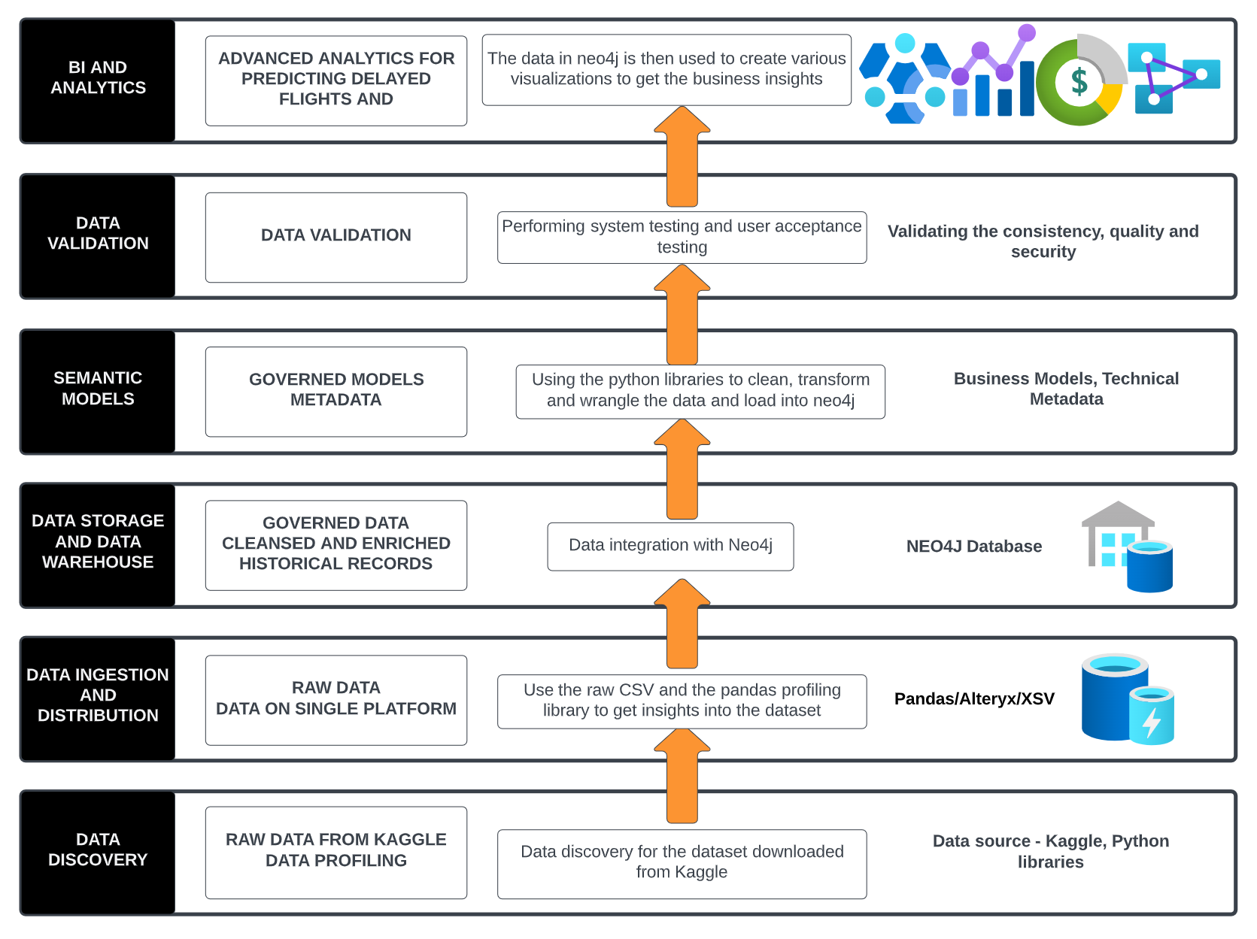

**Tableau**

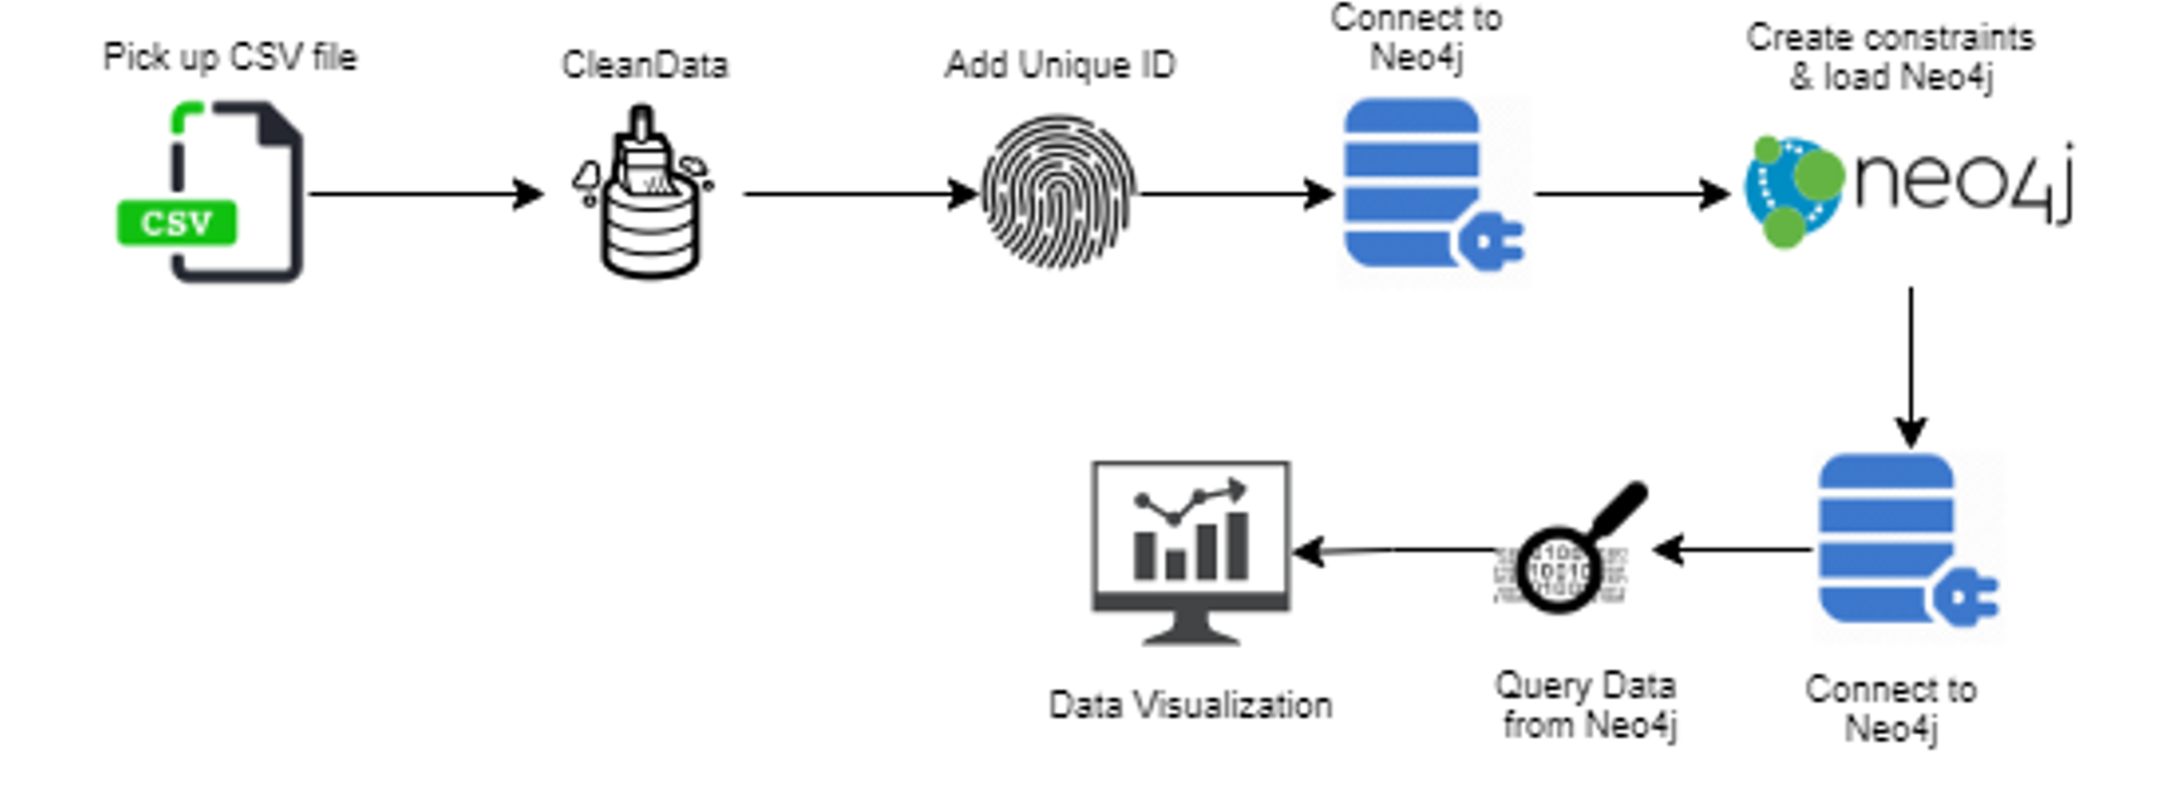

Tableau

### Graph Data Model

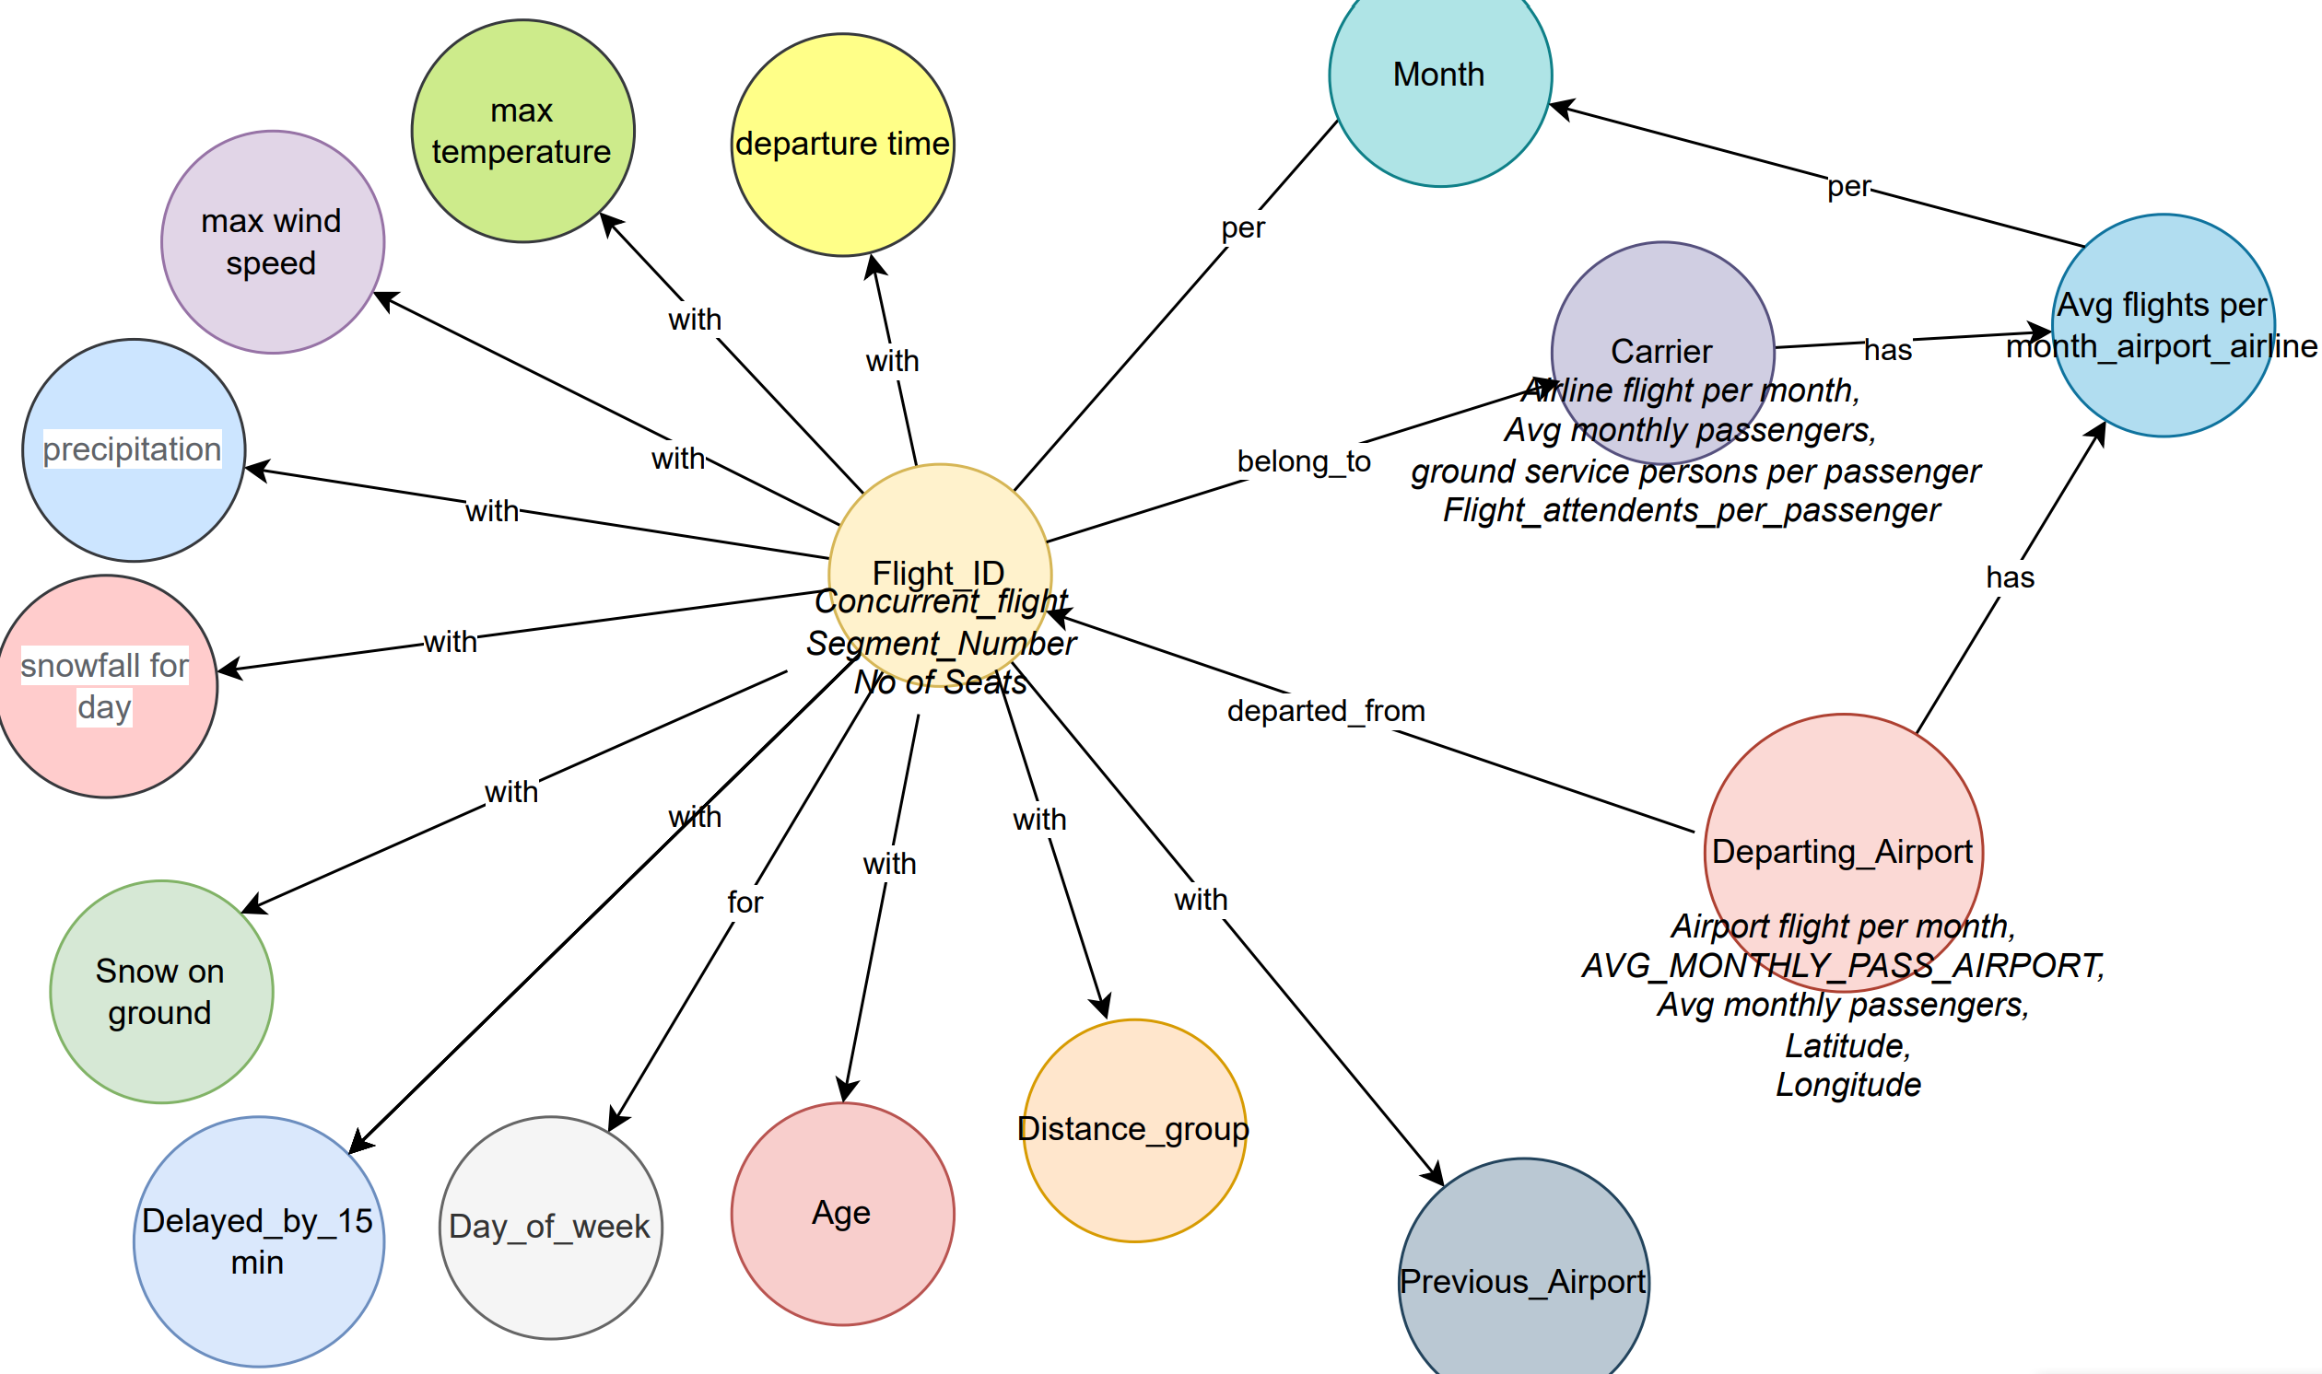

## Data Profiling

Classification dataset with detailed airline, weather, airport and employment information. Optional cancellation and delay reasons for multiclass applications.

This is a classification dataset with detailed airline, weather, airport and employment information. If using the included train/test precombined data, the problem is a binary classification evaluating a delayed departure. All raw data files are also included for customization of the dataset, including adding cancellation, specific delay reasons, and/or arrival delays to create a multiclass problem. Monthly data is included for 2019.

### Pandas Profiling Report

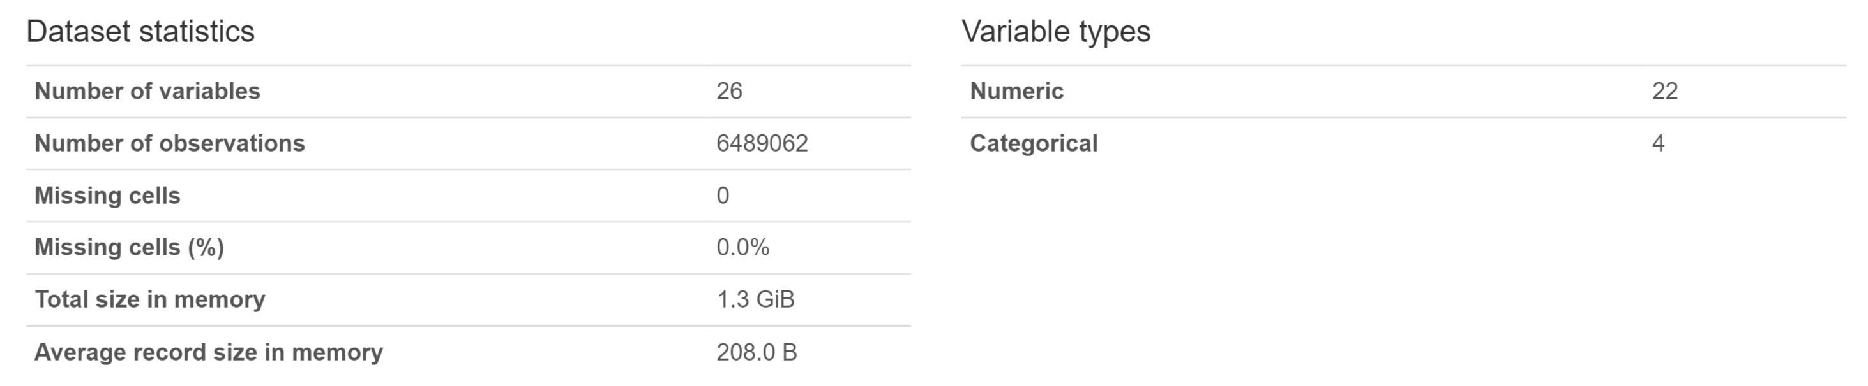

### Pandas Profiling warnings

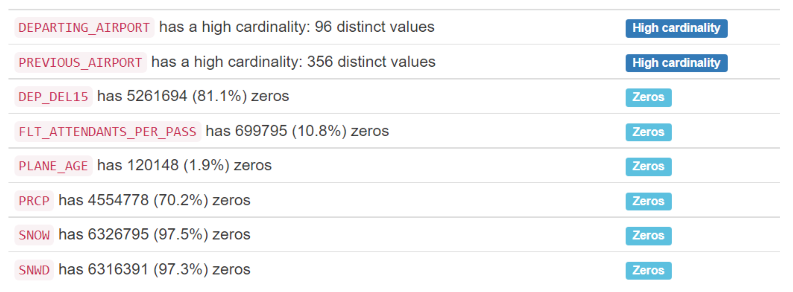

As the dataset is exceptionally large it has a high degree of cardinality which may cause issues when inserting into neo4j if not done properly.

### Column Profiling

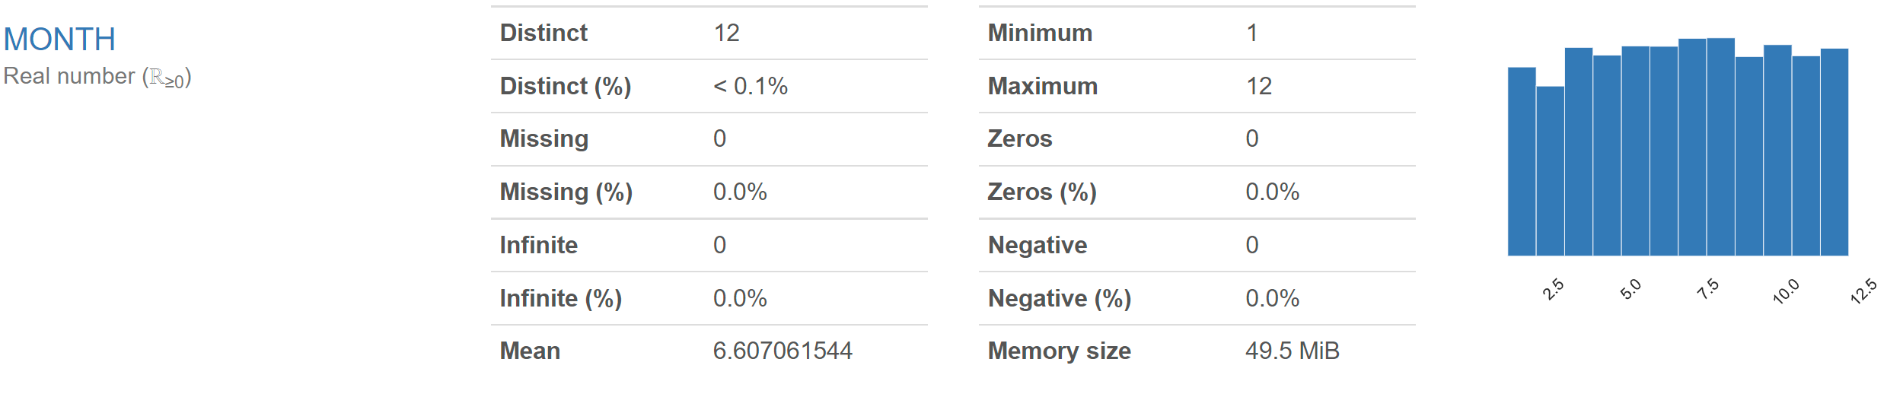

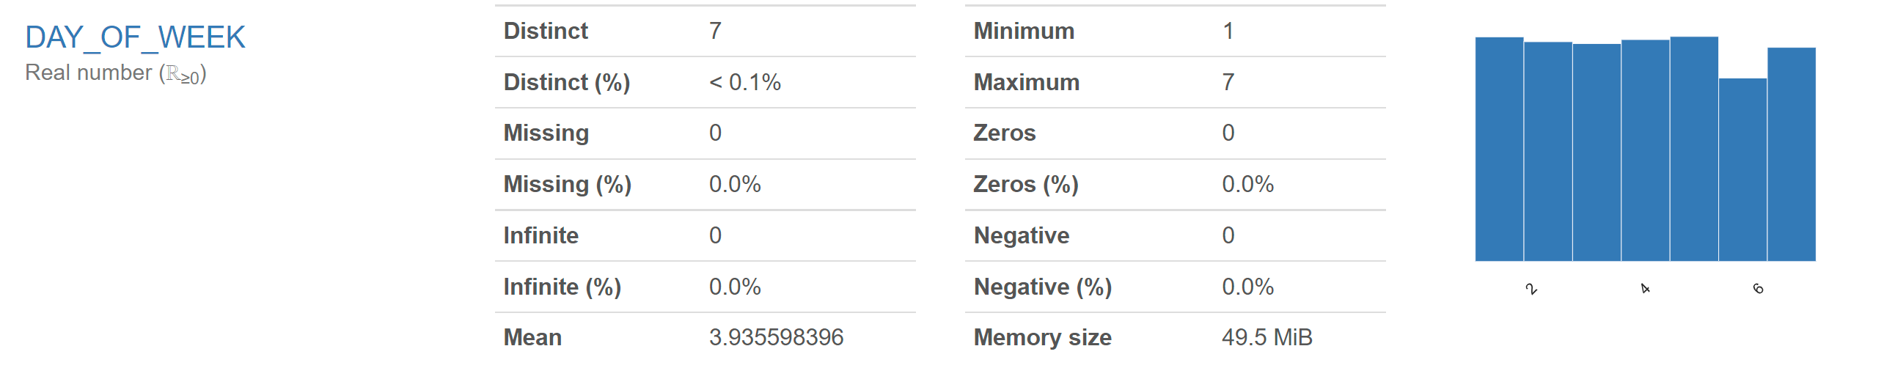

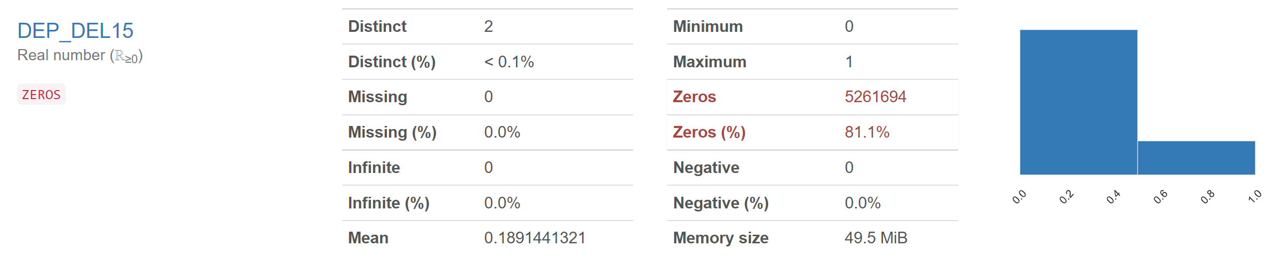

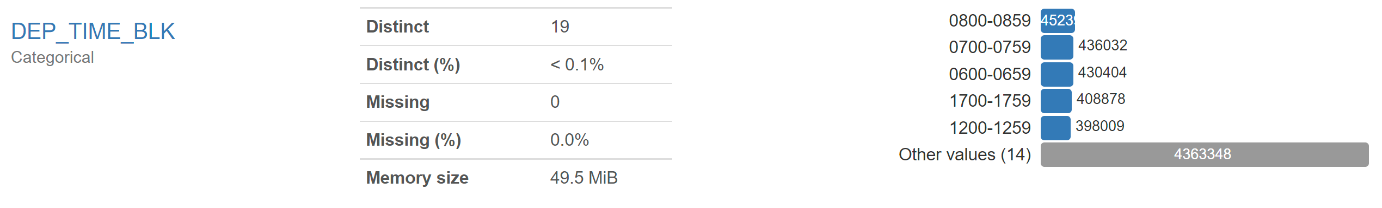

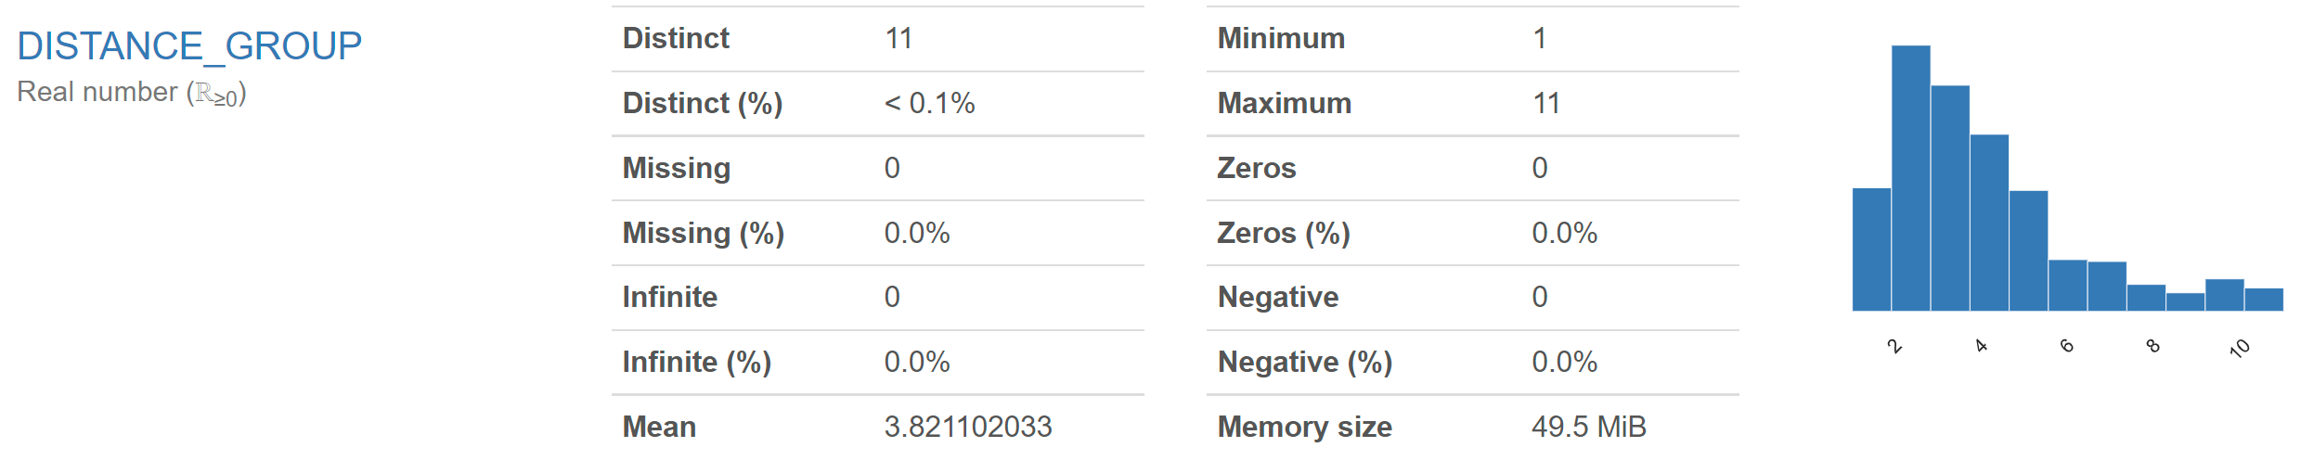

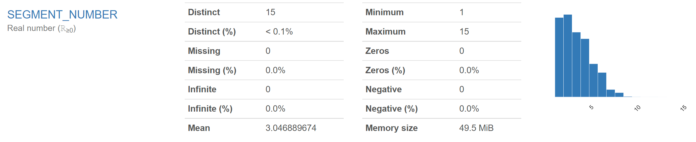

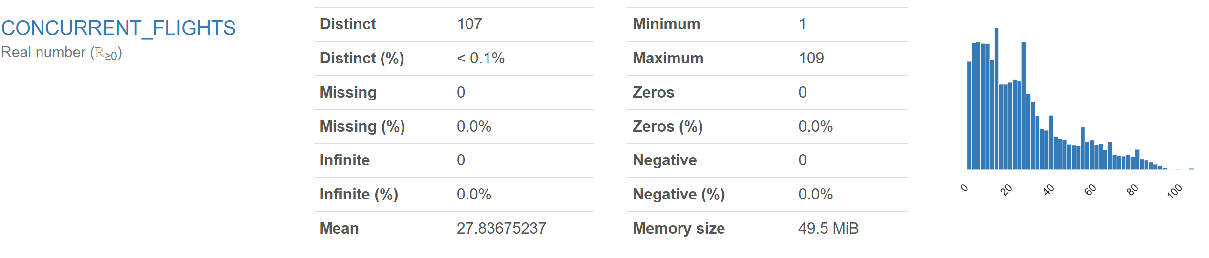

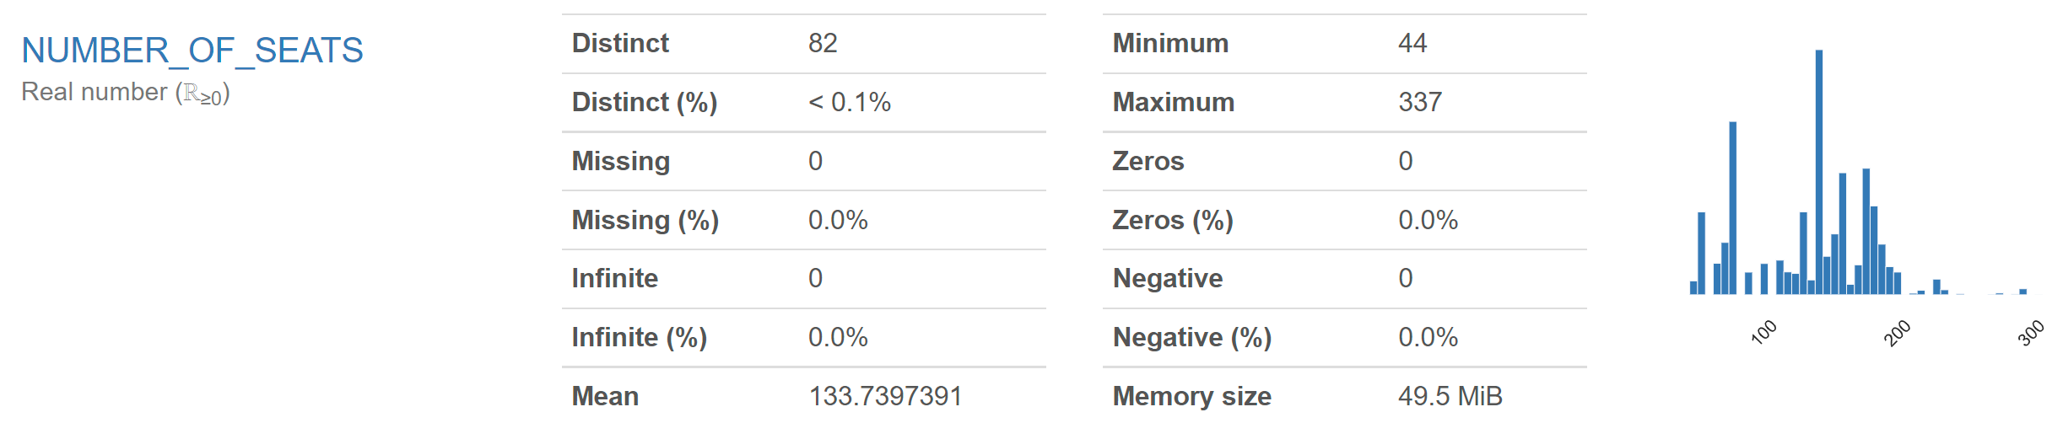

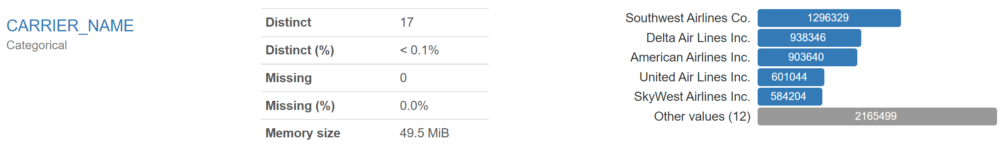

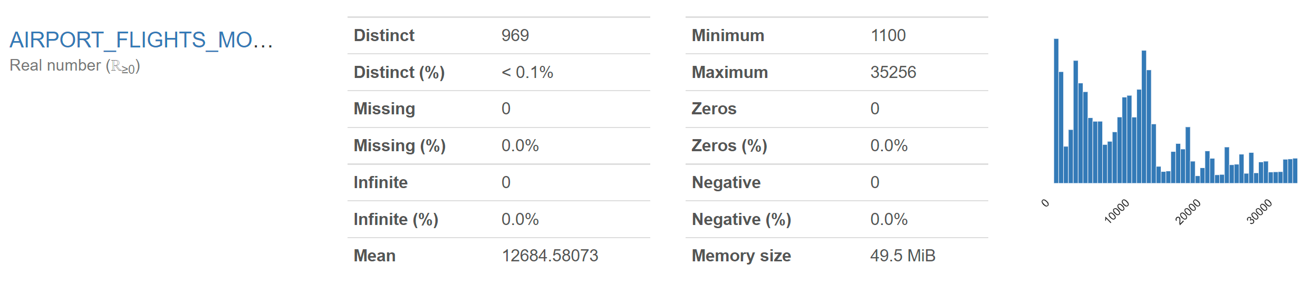 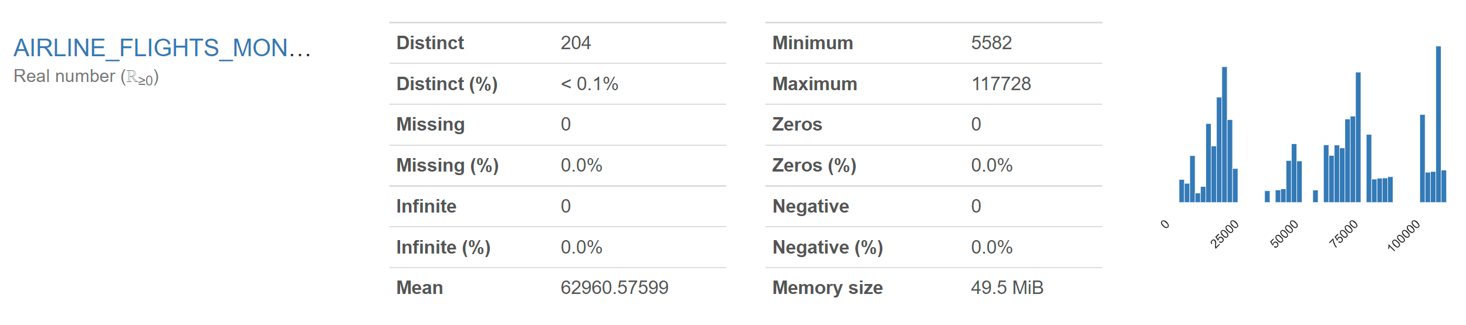 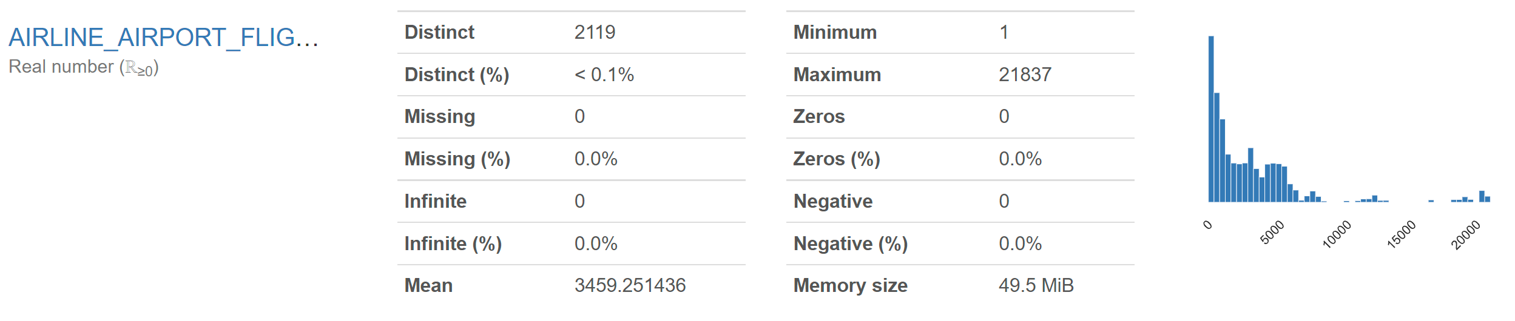

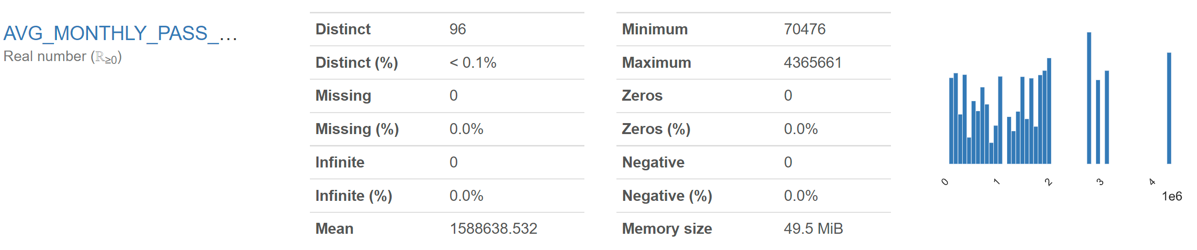 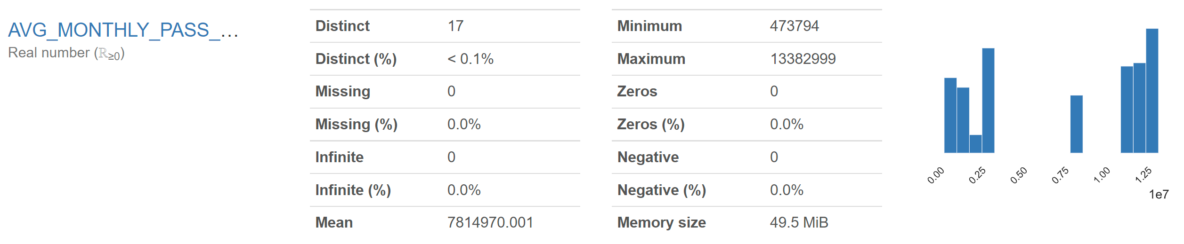 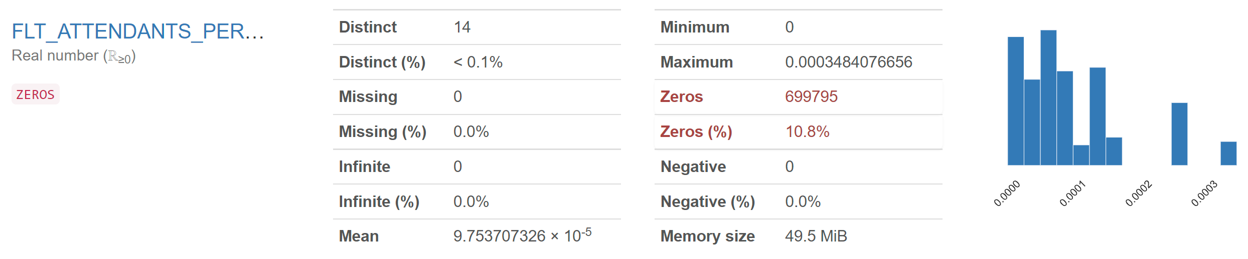 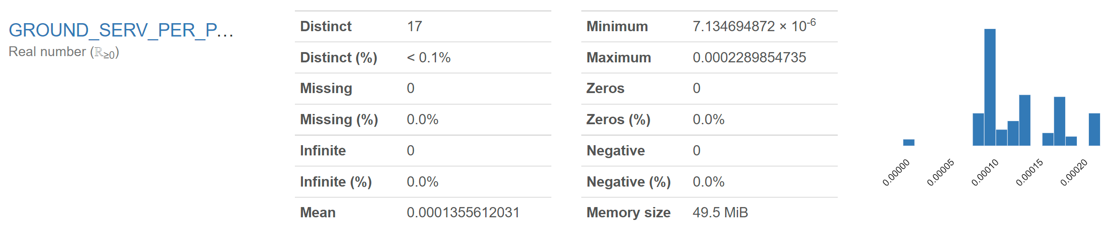

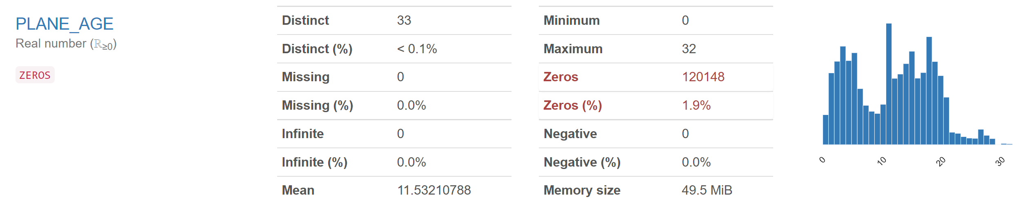

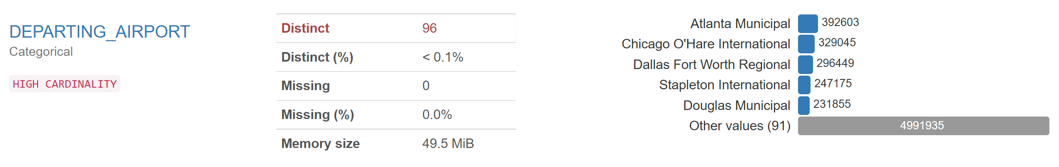

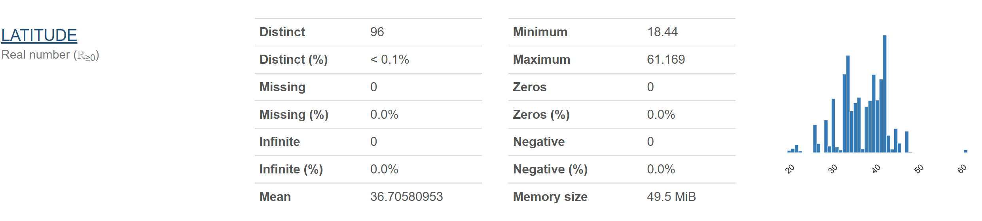

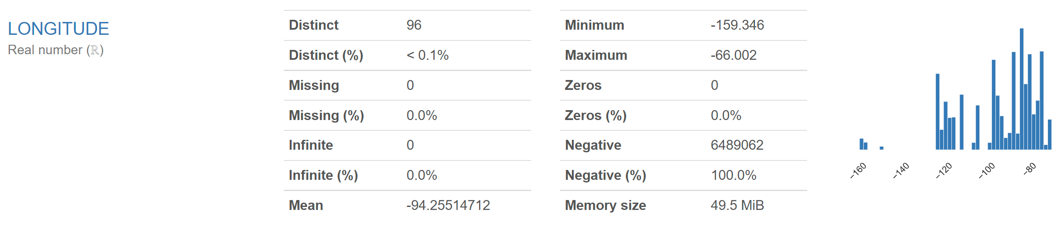

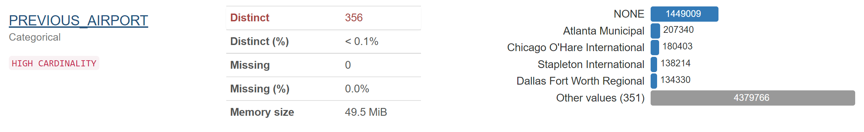

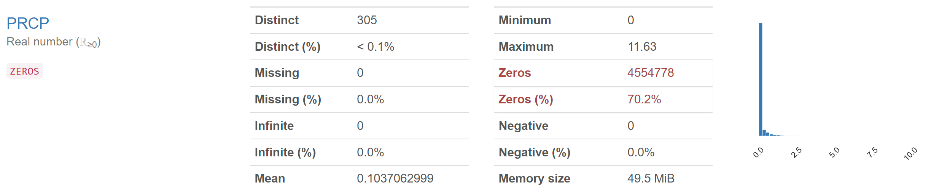

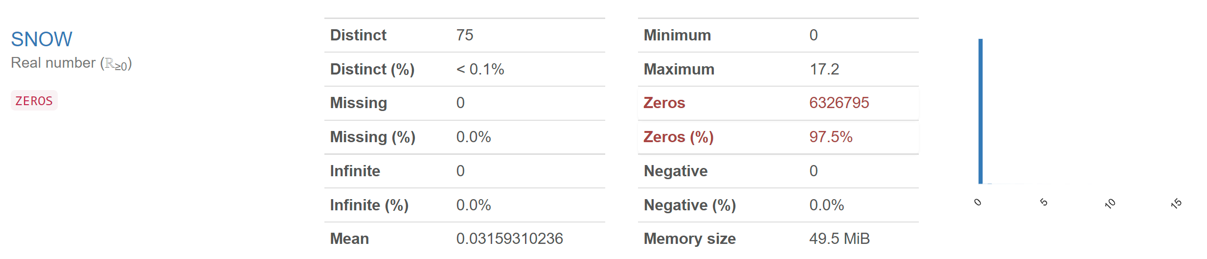

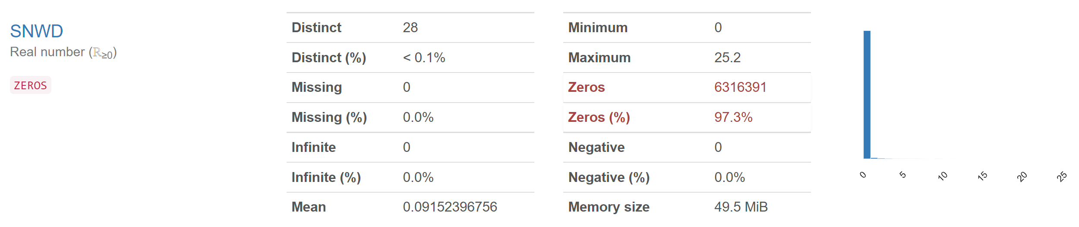

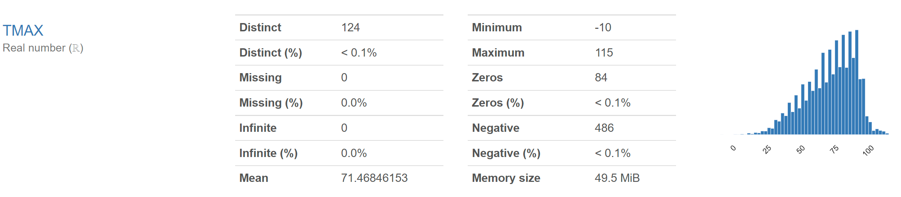

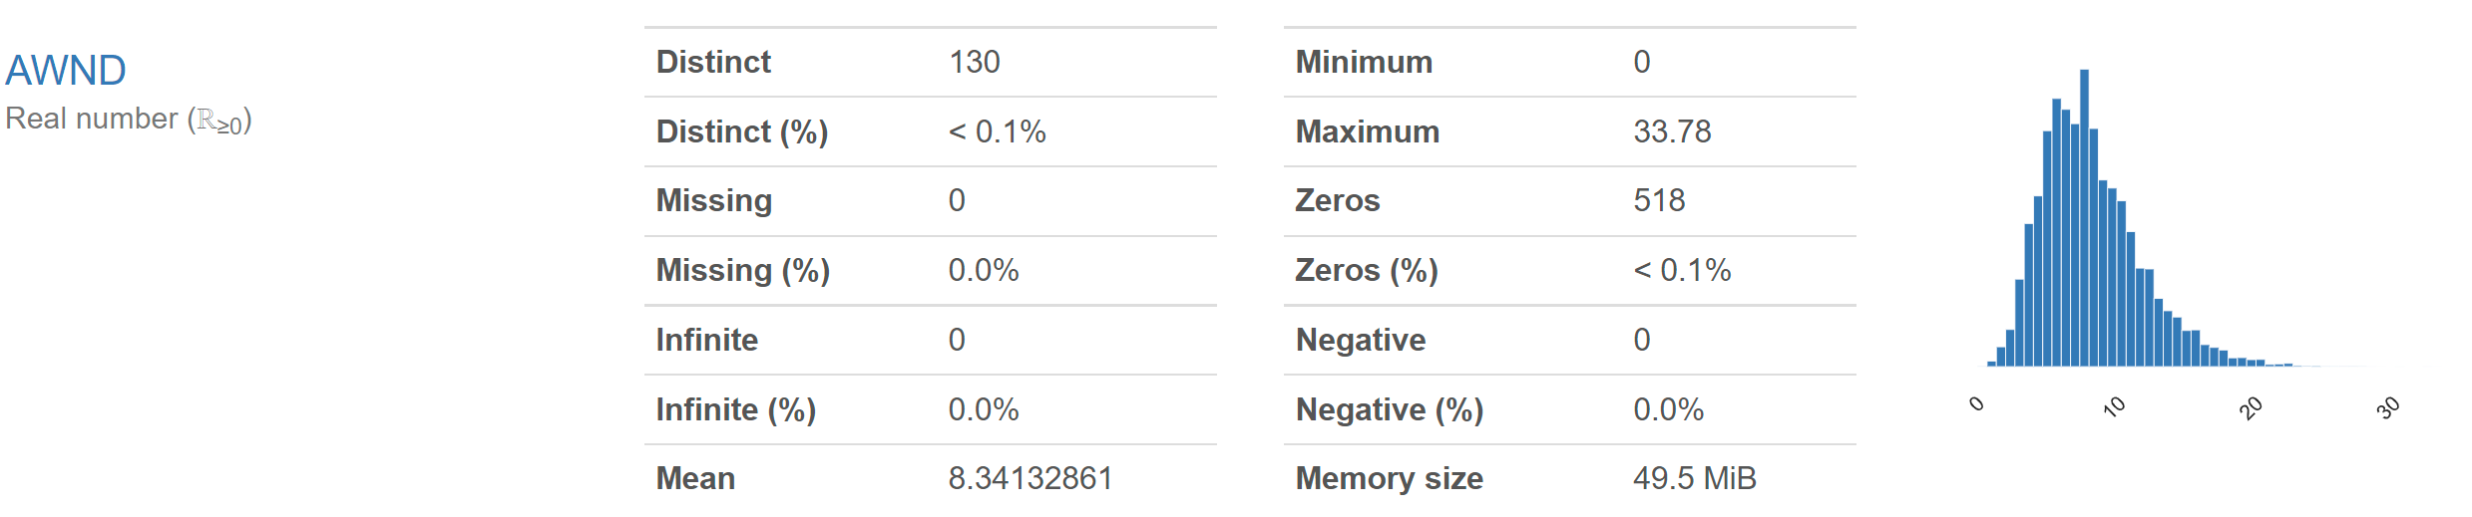

## Data Wrangling and Cleansing

After profiling the data, we can move ahead with cleaning the data according to the columns. The dataset already has a high level of usability, but a certain degree of wrangling and cleaning must be done before inserting the data into the database. The following steps were taken to ensure this:

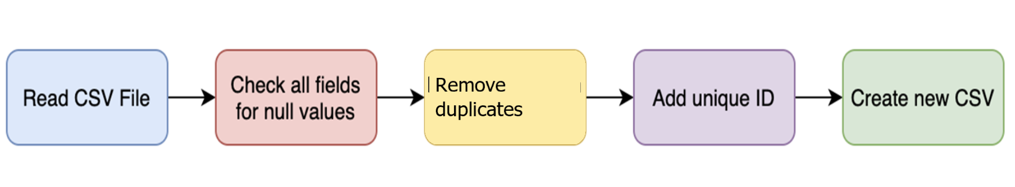

* Duplicate values were removed
* As an added check – all columns were checked for null/empty values. No columns had null values.
* As part of the data wrangling and cleansing process – a unique identifier was added to each record in the file.
* Alteryx was used to add Unique ID to the dataset
* The other fields in the dataset were clean and did not require any added data wrangling or cleansing.

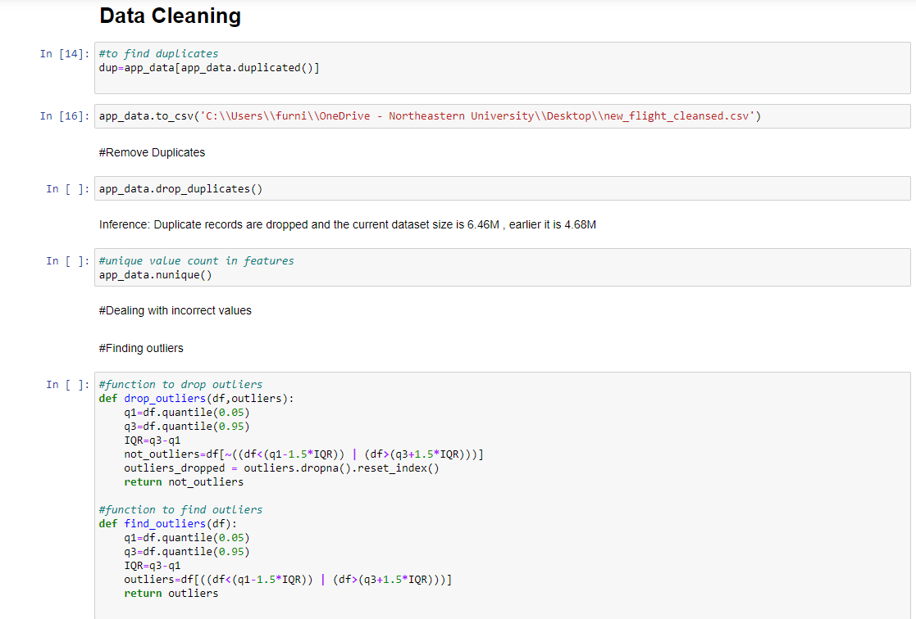

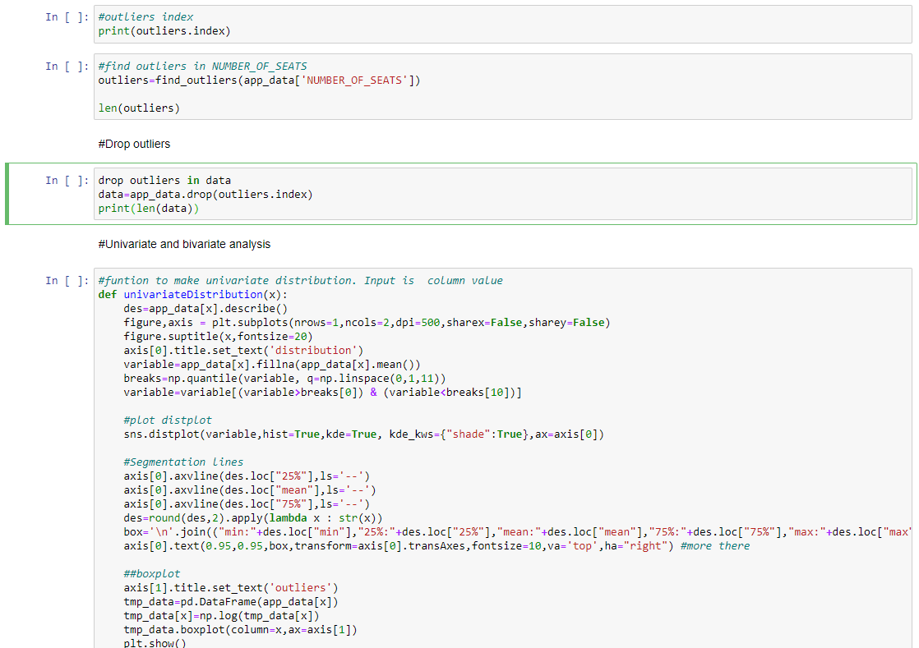

## Database Installation

### Mac Installation (dmg)

The installer includes the Java version needed for running Neo4j.

* Open the dmg file you just downloaded.
* Drag the Neo4j icon into your Applications folder. Watch the video to see this in action.
* Open Neo4j from your Applications folder. You might need to acknowledge that you downloaded the application from the Internet.
* Click on the Start button to start the Neo4j server.
* Open the provided URL in your local web browser.
* Change the password for the neo4j account.

### Windows

* The installer includes the Java version needed for running Neo4j.
* Launch the installer you just downloaded. You might have to give the installer permission to make changes to your computer.
* Follow the prompts and choose the option to Run Neo4j.
* Click on the Start button to start the Neo4j server.
* Open the provided URL in your local web browser.
* Change the password for the neo4j account.

### Create and Configure Database

* Open Neo4j
* From the Neo4j Desktop home screen, create a new project.
* Give the new project a name and click on the + icon to create a new Local DBMS.
* Provide the Database name and password to create the new database.
* Once the database is created – start the database and open the Neo4j Browser which will allow you to run queries.

## Data Mapping and Integration

After cleaning and wrangling the raw dataset – the data is loaded to Neo4j.

### Data Mapping

The below table illustrates the fields in the source CSV fields and their mapping to Neo4j nodes and corresponding properties for the respective nodes.

|  |  |  |
| --- | --- | --- |
| **Raw CSV Field** | **Node** | **Property** |
| Flight_ID | Flight | FlightID |
| CONCURRENT_FLIGHTS | Flight | CONCURRENT_FLIGHTS |
| SEGMENT_NUMBER | Flight | SEGMENT_NUMBER |
| NUMBER_OF_SEATS | Flight | NUMBER_OF_SEATS |
| AIRLINE_FLIGHTS_MONTH | Carrier | AIRLINE_FLIGHTS_MONTH |
| AVG_MONTHLY_PASSENGERS_AIRLINE | Carrier | AVG_MONTHLY_PASS_AIRLINE |
| GROUND_SERV_PER_PASS | Carrier | GROUND_SERV_PER_PASS |
| FLT_ATTENDANTS_PER_PASS | Carrier | FLT_ATTENDANTS_PER_PASS |
| Carrier_Name | Carrier | CARRIER_NAME |
| AIRLINE_AIRPORT_FLIGHTS_MONTH | airline_airport_flights | AIRLINE_AIRPORT_FLIGHTS_MONTH |
| DEPARTING_AIRPORT | airport | Departing_Airport |
| AIRPORT_FLIGHTS_MONTH | airport | AIRPORT_FLIGHTS_MONTH |
| AVG_MONTHLY_PASSENGERS_AIRPORT | airport | Avg_monthly_pass_airport |
| LATITUDE | airport | Latitude |
| LONGITUDE | airport | Longitude |
| Month | Month | Month |
| PREVIOUS_AIRPORT | PREVIOUS_AIRPORT | PREVIOUS_AIRPORT |
| DISTANCE_GROUP | DISTANCE_GROUP | DISTANCE_GROUP |
| PLANE_AGE | Age | PLANE_AGE |
| DAY_OF_WEEK | Day_of_week | DAY_OF_WEEK |
| Dep_Del15 | DEP_DEL15 | DEP_DEL15 |
| SNWD | Snow on ground | SNWD |
| SNOW | Snow fall for day | SNOW |
| PRCP | Precipitation | PRCP |
| AWND | Max wind speed | AWND |
| TMAX | Max temperature | TMAX |
| DEP_TIME_BLK | Departure Time | DEP_TIME_BLK |

### Data Integration

**Method of Integration: Data Pipeline**  
**Language: Python**

* Complete end-to-end integration is made possible with the help of a data pipeline.
* To integrate both the cleansing and loading process, the pipeline takes the source file as the input, cleans, and transforms the data and loads the Neo4j database.

### Workflow

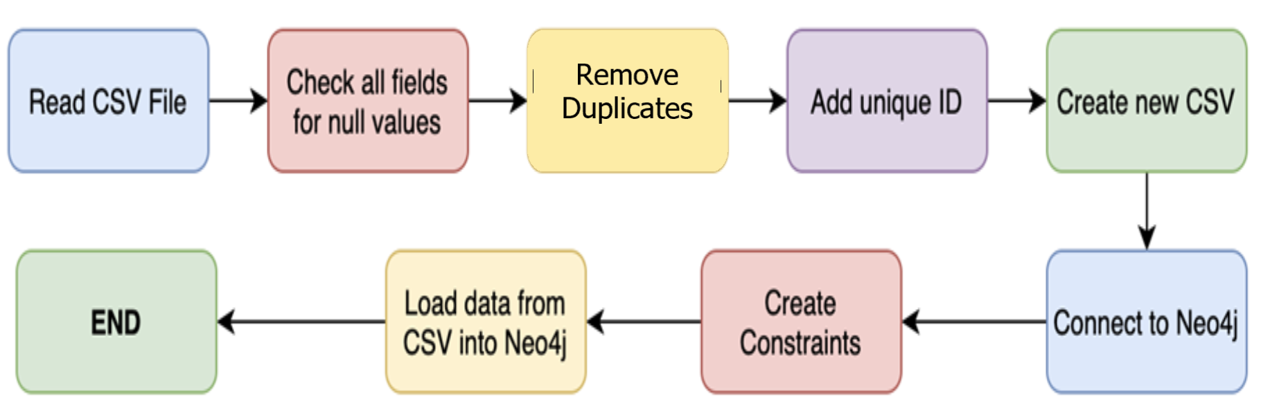

### Cypher To load Neo4j

**//Creating constraints for the data**

CREATE CONSTRAINT ON (flight:Flight) ASSERT flight.FlightID IS UNIQUE;

CREATE CONSTRAINT ON (carrier:CARRIER_NAME) ASSERT carrier.CARRIER_NAME IS UNIQUE;

CREATE CONSTRAINT ON (airport:DEPARTING_AIRPORT) ASSERT airport.DEPARTING_AIRPORT IS UNIQUE;

CREATE CONSTRAINT ON (airline_airport:AIRLINE_AIRPORT_FLIGHTS_MONTH) ASSERT airline_airport.AIRLINE_AIRPORT_FLIGHTS_MONTH IS UNIQUE;

CREATE CONSTRAINT ON (age:PLANE_AGE) ASSERT age.PLANE_AGE IS UNIQUE;

CREATE CONSTRAINT ON (previousAirport:PREVIOUS_AIRPORT) ASSERT previousAirport.PREVIOUS_AIRPORT IS UNIQUE;

CREATE CONSTRAINT ON (distanceGrp:DISTANCE_GROUP) ASSERT distanceGrp.DISTANCE_GROUP IS UNIQUE;

CREATE CONSTRAINT ON (departuretime:DEP_TIME_BLK) ASSERT departuretime.DEP_TIME_BLK IS UNIQUE;

CREATE CONSTRAINT ON (delay:DEP_DEL15) ASSERT delay.DEP_DEL15 IS UNIQUE;

CREATE CONSTRAINT ON (month:MONTH) ASSERT month.MONTH IS UNIQUE;

CREATE CONSTRAINT ON (weekDay:DAY_OF_WEEK) ASSERT weekDay.DAY_OF_WEEK IS UNIQUE;

CREATE CONSTRAINT ON (Precipitation:PRCP) ASSERT Precipitation.PRCP IS UNIQUE;

CREATE CONSTRAINT ON (SnowGround:SNWD) ASSERT SnowGround.SNWD IS UNIQUE;

CREATE CONSTRAINT ON (Snow:SNOW)ASSERT Snow.SNOW IS UNIQUE;

CREATE CONSTRAINT ON (MaxTemp:TMAX)ASSERT MaxTemp.TMAX IS UNIQUE;

CREATE CONSTRAINT ON (Wind:AWND)ASSERT Wind.AWND IS UNIQUE;

// Create flight node

:auto USING PERIODIC COMMIT 500

LOAD CSV With HEADERS FROM 'file:///Cleansed_flights.csv' AS row

MERGE

(flight:Flight {FlightID:row.Flight_ID})

ON CREATE SET flight.NUMBER_OF_SEATS = row.NUMBER_OF_SEATS,flight.CONCURRENT_FLIGHTS = row.CONCURRENT_FLIGHTS,flight.SEGMENT_NUMBER = row.SEGMENT_NUMBER;

//

// Create CARRIER Node

:auto USING PERIODIC COMMIT 500

LOAD CSV With HEADERS FROM 'file:///Cleansed_flights.csv' AS row

MERGE

(carrier:CARRIER{CARRIER_NAME:row.CARRIER_NAME})

ON CREATE SET carrier.AIRLINE_FLIGHTS_MONTH=row.AIRLINE_FLIGHTS_MONTH, carrier.AVG_MONTHLY_PASS_AIRLINE=row.AVG_MONTHLY_PASS_AIRLINE, carrier.GROUND_SERV_PER_PASS=row.GROUND_SERV_PER_PASS, carrier.Flight_attendents_per_passenger = row.FLT_ATTENDANTS_PER_PASS

;

//

// Load AIRPORT node

:auto USING PERIODIC COMMIT 500

LOAD CSV With HEADERS FROM 'file:///Cleansed_flights.csv' AS row

MERGE

(airport:AIRPORT {DEPARTING_AIRPORT: row.DEPARTING_AIRPORT})

ON CREATE SET airport.LATITUDE=row.LATITUDE,airport.LONGITUDE=row.LONGITUDE,airport.AVG_MONTHLY_PASS_AIRPORT=row.AVG_MONTHLY_PASS_AIRPORT,airport.AIRPORT_FLIGHTS_MONTH=row.AIRPORT_FLIGHTS_MONTH;

//

// Create airline_airports__monthly flights Node

:auto USING PERIODIC COMMIT 500

LOAD CSV With HEADERS FROM 'file:///Cleansed_flights.csv' AS row

MERGE

(monthlyflights:airline_airport_flights{AIRLINE_AIRPORT_FLIGHTS_MONTH:row.AIRLINE_AIRPORT_FLIGHTS_MONTH});

//

// Create departure time Node

:auto USING PERIODIC COMMIT 500

LOAD CSV With HEADERS FROM 'file:///Cleansed_flights.csv' AS row

MERGE

(departuretime:DEP_TIME_BLK{DEP_TIME_BLK:row.DEP_TIME_BLK});

//

// Create dayweek Node

:auto USING PERIODIC COMMIT 500

LOAD CSV With HEADERS FROM 'file:///Cleansed_flights.csv' AS row

MERGE

(weekDay:DAY_OF_WEEK{DAY_OF_WEEK:row.DAY_OF_WEEK});

//

// Create age:PLANE_AGE Node

:auto USING PERIODIC COMMIT 500

LOAD CSV With HEADERS FROM 'file:///Cleansed_flights.csv' AS row

MERGE

(age:PLANE_AGE{PLANE_AGE:row.PLANE_AGE});

//

// Create delay Node

:auto USING PERIODIC COMMIT 500

LOAD CSV With HEADERS FROM 'file:///Cleansed_flights.csv' AS row

MERGE

(delay:DEP_DEL15{DEP_DEL15:row.DEP_DEL15});

//

//create previousAirport node

:auto USING PERIODIC COMMIT 500

LOAD CSV With HEADERS FROM 'file:///Cleansed_flights.csv' AS row

MERGE

(previousAirport:PREVIOUS_AIRPORT{PREVIOUS_AIRPORT:row.PREVIOUS_AIRPORT});

//

//create distance group distanceGrp:DISTANCE_GROUP

:auto USING PERIODIC COMMIT 500

LOAD CSV With HEADERS FROM 'file:///Cleansed_flights.csv' AS row

MERGE

(distanceGrp:DISTANCE_GROUP{DISTANCE_GROUP:row.DISTANCE_GROUP});

//

//create MONTH

:auto USING PERIODIC COMMIT 500

LOAD CSV With HEADERS FROM 'file:///Cleansed_flights.csv' AS row

MERGE

(month:MONTH{MONTH:row.MONTH});

//

//create Precipitation:PRCP

:auto USING PERIODIC COMMIT 500

LOAD CSV With HEADERS FROM 'file:///Cleansed_flights.csv' AS row

MERGE

(Precipitation:PRCP{PRCP:row.PRCP});

//

//create Snow

:auto USING PERIODIC COMMIT 500

LOAD CSV With HEADERS FROM 'file:///Cleansed_flights.csv' AS row

MERGE

(Snow:SNOW{Snow:row.SNOW});

//

//create MaxTemp

:auto USING PERIODIC COMMIT 500

LOAD CSV With HEADERS FROM 'file:///Cleansed_flights.csv' AS row

MERGE

(MaxTemp:TMAX{TMAX:row.TMAX});

//

//create Wind

:auto USING PERIODIC COMMIT 500

LOAD CSV With HEADERS FROM 'file:///Cleansed_flights.csv' AS row

MERGE

(Wind:AWND{Wind:row.AWND});

//

//create snowground

:auto USING PERIODIC COMMIT 500

LOAD CSV With HEADERS FROM 'file:///Cleansed_flights.csv' AS row

MERGE

(SnowGround:SNWD{SNWD:row.SNWD});

//

// Create Constrains build reltionship

//flight and carrier

:auto USING PERIODIC COMMIT 500

LOAD CSV With HEADERS FROM 'file:///Cleansed_flights.csv' AS row

MATCH (flight:Flight {FlightID:row.Flight_ID})

MATCH (carrier:CARRIER {CARRIER_NAME:row.CARRIER_NAME})

MERGE (flight)-[:BELONG_TO]->(carrier)

;

//

// flight and airport

:auto USING PERIODIC COMMIT 500

LOAD CSV With HEADERS FROM 'file:///Cleansed_flights.csv' AS row

MATCH (flight:Flight {FlightID:row.Flight_ID})

MATCH (airport:AIRPORT {DEPARTING_AIRPORT: row.DEPARTING_AIRPORT})

MERGE (flight)-[:Departed_from]->(airport)

;

//

// Airline airport monthly flights relationships

:auto USING PERIODIC COMMIT 500

LOAD CSV With HEADERS FROM 'file:///Cleansed_flights.csv' AS row

MATCH (flight:Flight {FlightID:row.Flight_ID})

MATCH (monthlyflights:airline_airport_flights{AIRLINE_AIRPORT_FLIGHTS_MONTH:row.AIRLINE_AIRPORT_FLIGHTS_MONTH})

MERGE (flight)-[:HAS]->(monthlyflights)

;

//

//

:auto USING PERIODIC COMMIT 500

LOAD CSV With HEADERS FROM 'file:///Cleansed_flights.csv' AS row

MATCH (airport:AIRPORT {DEPARTING_AIRPORT: row.DEPARTING_AIRPORT})

MATCH (monthlyflights:airline_airport_flights{AIRLINE_AIRPORT_FLIGHTS_MONTH:row.AIRLINE_AIRPORT_FLIGHTS_MONTH})

MERGE (airport)-[:HAS]->(monthlyflights)

;

//

// with month

:auto USING PERIODIC COMMIT 500

LOAD CSV With HEADERS FROM 'file:///Cleansed_flights.csv' AS row

MATCH (month:MONTH{MONTH:row.MONTH})

MATCH (monthlyflights:airline_airport_flights{AIRLINE_AIRPORT_FLIGHTS_MONTH:row.AIRLINE_AIRPORT_FLIGHTS_MONTH})

MERGE (monthlyflights)-[:FOR]->(month)

;

//

// Flight with month

:auto USING PERIODIC COMMIT 500

LOAD CSV With HEADERS FROM 'file:///Cleansed_flights.csv' AS row

MATCH (month:MONTH{MONTH:row.MONTH})

MATCH (flight:Flight {FlightID:row.Flight_ID})

MERGE (flight)-[:FOR]->(month)

;

//FLIGHT AND Departure time

:auto USING PERIODIC COMMIT 500

LOAD CSV With HEADERS FROM 'file:///Cleansed_flights.csv' AS row

MATCH (flight:Flight {FlightID:row.Flight_ID})

MATCH (departuretime:DEP_TIME_BLK{DEP_TIME_BLK:row.DEP_TIME_BLK})

MERGE (flight)-[:WITH]->(departuretime)

;

//FLIGHT AND Delay

:auto USING PERIODIC COMMIT 500

LOAD CSV With HEADERS FROM 'file:///Cleansed_flights.csv' AS row

MATCH (flight:Flight {FlightID:row.Flight_ID})

MATCH (delay:DEP_DEL15{DEP_DEL15:row.DEP_DEL15})

MERGE (flight)-[:WITH]->(delay)

;

//FLIGHT AND DayofWeek

:auto USING PERIODIC COMMIT 500

LOAD CSV With HEADERS FROM 'file:///Cleansed_flights.csv' AS row

MATCH (flight:Flight {FlightID:row.Flight_ID})

MATCH (weekDay:DAY_OF_WEEK{DAY_OF_WEEK:row.DAY_OF_WEEK})

MERGE (flight)-[:FOR]->(weekDay)

;

//FLIGHT AND Distance Group

:auto USING PERIODIC COMMIT 500

LOAD CSV With HEADERS FROM 'file:///Cleansed_flights.csv' AS row

MATCH (flight:Flight {FlightID:row.Flight_ID})

MATCH (distanceGrp:DISTANCE_GROUP{DISTANCE_GROUP:row.DISTANCE_GROUP})

MERGE (flight)-[:WITH]->(distanceGrp)

;

//FLIGHT AND Age

:auto USING PERIODIC COMMIT 500

LOAD CSV With HEADERS FROM 'file:///Cleansed_flights.csv' AS row

MATCH (flight:Flight {FlightID:row.Flight_ID})

MATCH (age:PLANE_AGE{PLANE_AGE:row.PLANE_AGE})

MERGE (flight)-[:WITH]->(age)

;

//FLIGHT AND Previous Airport

:auto USING PERIODIC COMMIT 500

LOAD CSV With HEADERS FROM 'file:///Cleansed_flights.csv' AS row

MATCH (flight:Flight {FlightID:row.Flight_ID})

MATCH (previousAirport:PREVIOUS_AIRPORT{PREVIOUS_AIRPORT:row.PREVIOUS_AIRPORT})

MERGE (flight)-[:WITH]->(previousAirport)

;

//flight conditions

//FLIGHT AND TMAX

:auto USING PERIODIC COMMIT 500

LOAD CSV With HEADERS FROM 'file:///Cleansed_flights.csv' AS row

MATCH (flight:Flight {FlightID:row.Flight_ID})

MATCH (MaxTemp:TMAX{TMAX:row.TMAX})

MERGE (flight)-[:WITH]->(MaxTemp)

;

//FLIGHT AND PRCP

:auto USING PERIODIC COMMIT 500

LOAD CSV With HEADERS FROM 'file:///Cleansed_flights.csv' AS row

MATCH (flight:Flight {FlightID:row.Flight_ID})

MATCH (Precipitation:PRCP{PRCP:row.PRCP})

MERGE (flight)-[:WITH]->(Precipitation)

;

//FLIGHT AND SNOW

:auto USING PERIODIC COMMIT 500

LOAD CSV With HEADERS FROM 'file:///Cleansed_flights.csv' AS row

MATCH (flight:Flight {FlightID:row.Flight_ID})

MATCH (Snow:SNOW{Snow:row.SNOW})

MERGE (flight)-[:WITH]->(Snow)

;

//FLIGHT AND SNWD

:auto USING PERIODIC COMMIT 500

LOAD CSV With HEADERS FROM 'file:///Cleansed_flights.csv' AS row

MATCH (flight:Flight {FlightID:row.Flight_ID})

MATCH (SnowGround:SNWD{SNWD:row.SNWD})

MERGE (flight)-[:WITH]->(SnowGround)

;

//FLIGHT AND AWND

:auto USING PERIODIC COMMIT 500

LOAD CSV With HEADERS FROM 'file:///Cleansed_flights.csv' AS row

MATCH (flight:Flight {FlightID:row.Flight_ID})

MATCH (Wind:AWND{Wind:row.AWND})

MERGE (flight)-[:WITH]->(Wind)

;

### Neo4j Data Model

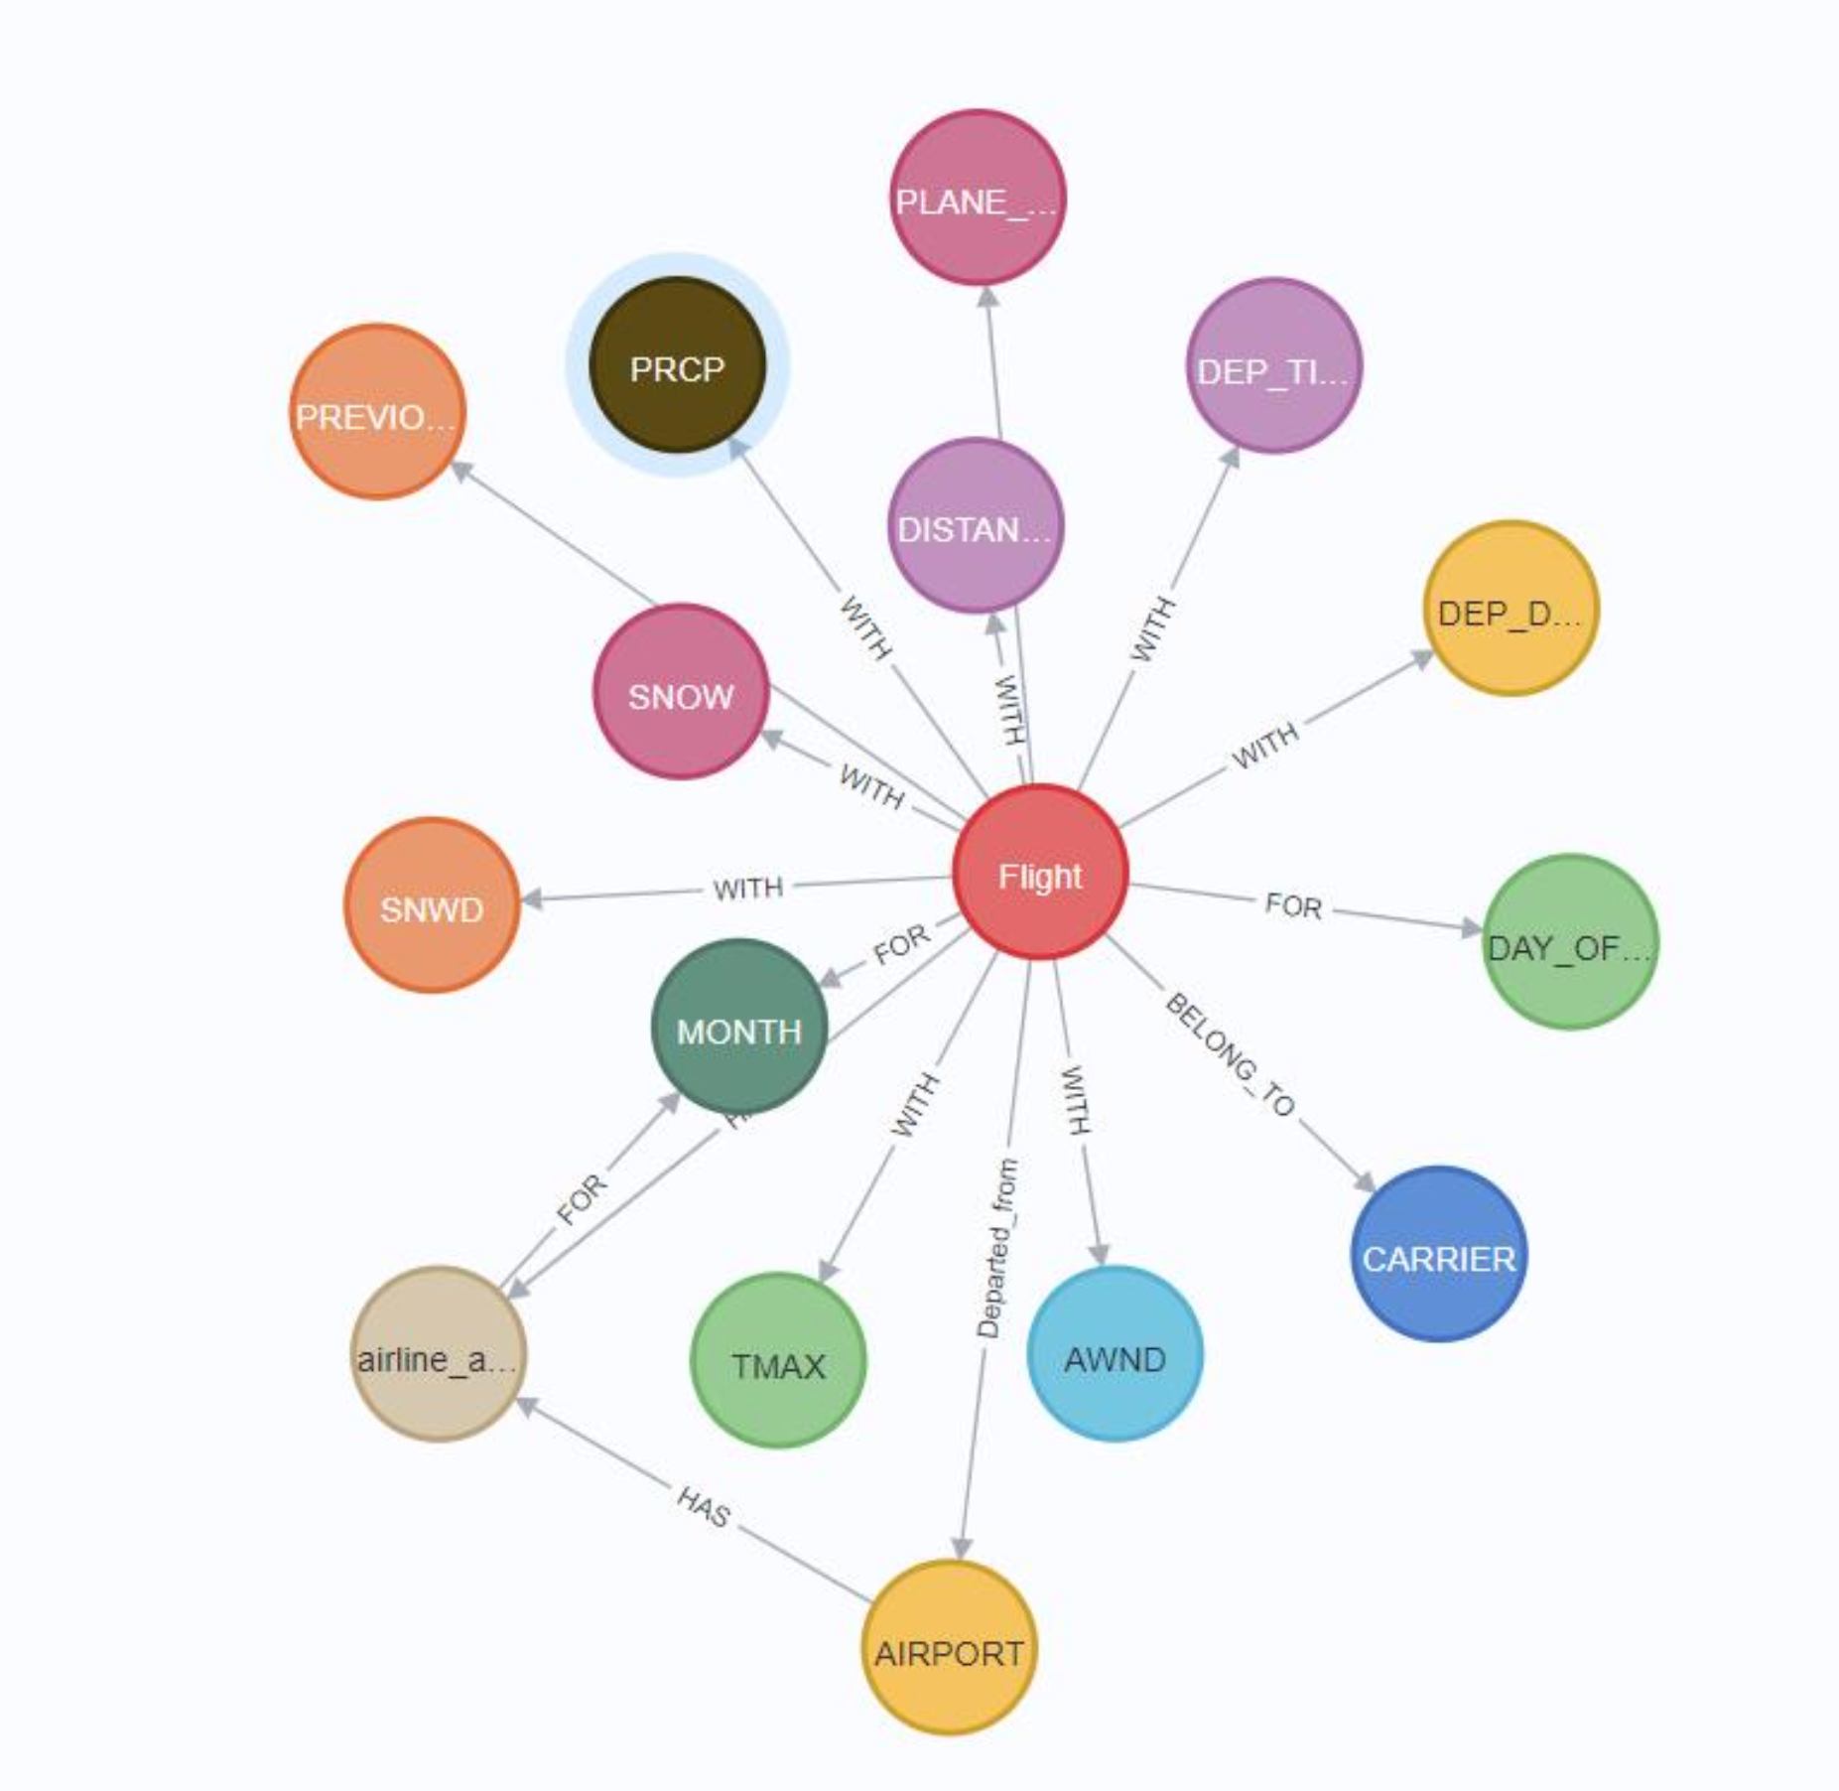

## Business and Technical Metadata

The technical metadata was extracted from the Neo4j database. This can be found in the metadata directory.

### Technical Metadata

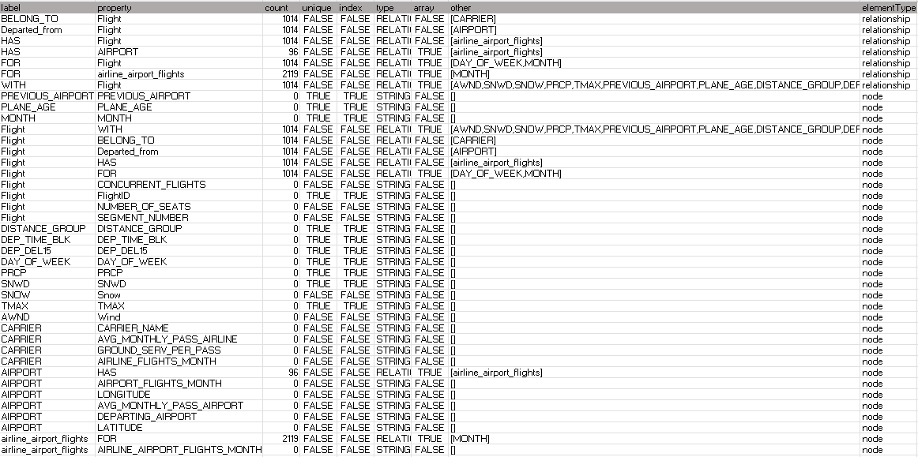

### Business Metadata

|  |  |  |
| --- | --- | --- |
| **Column Names** | **Column Description** | **Data Type** |
| Flight_ID | Unique ID for flight | Integer |
| CONCURRENT_FLIGHTS | Concurrent flights leaving from the airport in the same departure block | Integer |
| SEGMENT_NUMBER | The segment that this tail number is on for the day | Integer |
| NUMBER_OF_SEATS | Number of seats on the aircraft | Integer |
| AIRLINE_FLIGHTS_MONTH | Average flights per month for the airport | Integer |
| AVG_MONTHLY_PASSENGERS_AIRLINE | Average passengers per month for the airline | Integer |
| GROUND_SERV_PER_PASS | Ground service employees (service desk) per passenger for airline | Float |
| FLT_ATTENDANTS_PER_PASS | Flight attendants per passenger for airline | Float |
| Carrier_Name | Airline the flight belongs to | String |
| AIRLINE_AIRPORT_FLIGHTS_MONTH | Average flights per month for airline and airport | Integer |
| DEPARTING_AIRPORT | Departing airport name | String |
| AIRPORT_FLIGHTS_MONTH | Average flights per month for the airport | Integer |
| AVG_MONTHLY_PASSENGERS_AIRPORT | Average passengers per month for the departing airport | Integer |
| LATITUDE | Latitude for Departing Airport | Float |
| LONGITUDE | Longitude for Departing Airport | Float |
| Month | Month of the flight departure | Integer |
| PREVIOUS_AIRPORT | Previous airport that the aircraft departed from | String |
| DISTANCE_GROUP | Distance group to be flown by departing aircraft | Integer |
| PLANE_AGE | Age of departing aircraft | Integer |
| DAY_OF_WEEK | Day of week of the flight departure | Integer |
| Dep_Del15 | TARGET Binary of a departure delay over 15 minutes (1 is yes) | Integer |
| SNWD | Inches of snow on ground for day | Float |
| SNOW | Inches of snowfall for day | Float |
| PRCP | Inches of precipitation for day | Float |
| AWND | Max wind speed for day | Float |
| TMAX | Max Temperature for day | Float |
| DEP_TIME_BLK | Departure time of the flight | String (Time range) |

## Data Validation and Data Visualization

### Data Validation

Data Validation was done by comparing the data loaded on Neo4j with the data available in the raw CSV files.

**Flight Node on Neo4j for ID: 5**

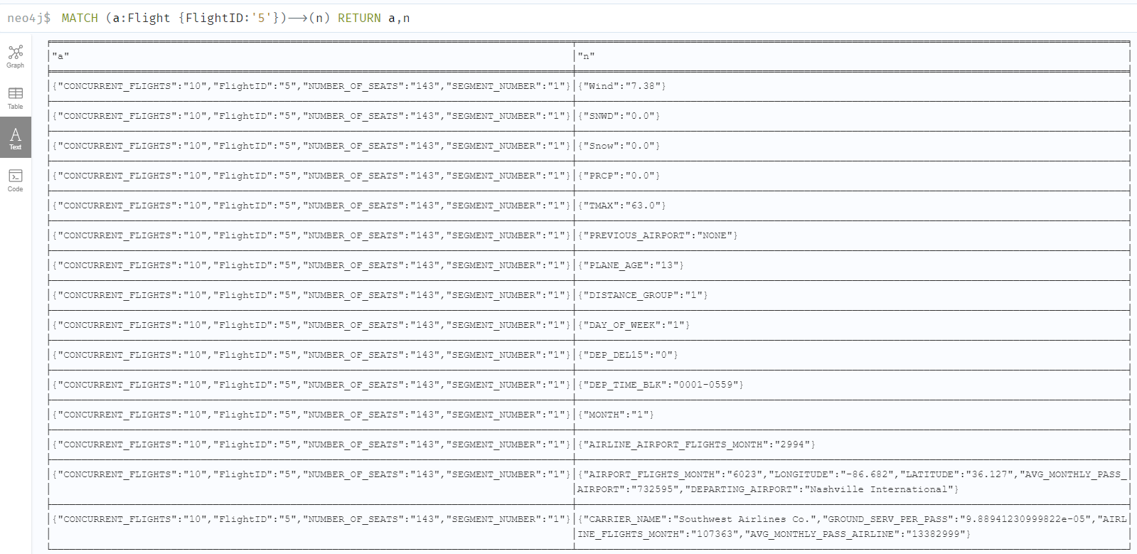

Flight record in Alteryx with Flight_ID :5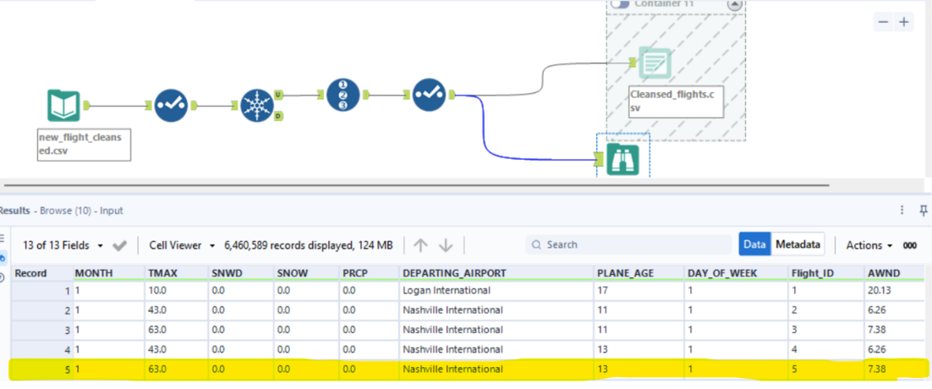

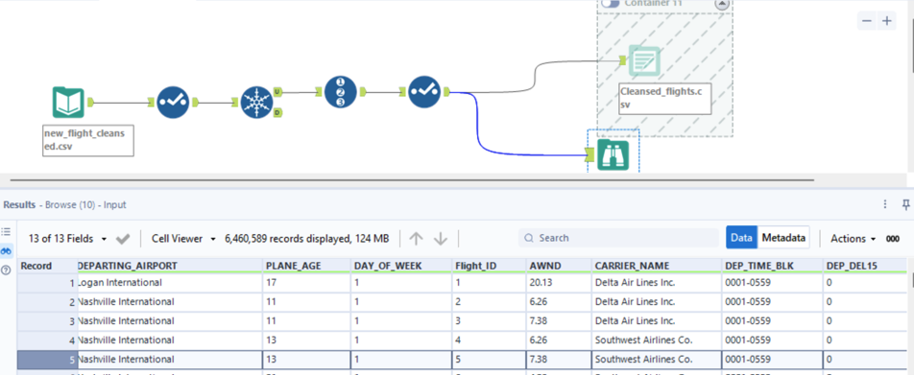

### Data visualization

**Data Visualization Tool: Tableau**

* The dashboard supplies value to potential business-users who would want to track and visualize global airline delays for the year 2019 in a single web application.
* The end-users would be business analysts who would want to track how much a flight is delayed across the year and what are the factors affecting those delays.
* The visualizations are designed and developed on a data visualization tool called Tableau.
* Business users need not create the reports or worksheets to get insights from the data – deploying the entire visualization and reporting framework as a web-application ensures that any business users can just visit the application on their browsers and view metrics.
* The dashboard/visualization offers multiple ways to slice and filter the data.
* In most of the visualizations – there is functionality to filter data.
* Filters in the visualizations allow users to slice the data as required.
* Filters are contextual, and change based on the selected visualization type.

**Why Tableau?**

* Tableau makes it extremely easy to deploy a stand-alone visualization as a web application.
* Easy to design, develop and maintain the dashboards.
* Extremely easy to integrate with the neo4j database.

### key insights derived from the visualizations

* Plane Age: 28% of the flight delays belong to the flights with age of 11-15 years.
* Airport: Airports from major cities like Chicago, Dallas, Atlanta seems to be busier and have more delays compared to other airports.
* Carrier: Southwest Airline company has the greatest number of flight delays in the year 2019. The top three carriers with the greatest number of flight delays contributed to nearly 50% of the total flight delays.
* Time Analysis: Most of the flights are delayed during evenings. In a week, it is observed that Saturday has the least number of flight delays whereas Thursday has highest delays.
* June has the highest number of delays, which is also due to the holiday rush. September has the least number of flight delays. The number of delays however do get high during December.
* Weather Conditions: For airports in colder states like Illinois and Colorado, up to 16% of flight delays were due to heavy snowfall in winters.
* There is a strong correlation between heavy rainfall and the flight delays. In the regions with moderate to heavy rainfall, it affects the flight delays.
* Flight delays are affected due to extreme temperatures (>100). We can see a spike in number of flight delays during the summers.

### Metrics being assessed and visualized

|  |  |  |
| --- | --- | --- |
| **Metrics** | **Description** | **New Measures** |
| Weather Analysis (Snow) | Gives the number of flight delays by months for the different snowfall level groups. | New measure created with grouping of snowfall levels |
| Weather Analysis (Temperature) | Gives the number of flight delays by months for the different temperature groups | New measure created with grouping of temperature. |
| Weather Analysis (Precipitation) | Gives the number of flight delays by months for the different precipitation groups | New measure created with grouping of precipitation levels. |
| Time Analysis (Part of Day) | Gives the number of flight delays during different parts of a day | Grouped the departure time and created a new measure |
| Plane Age | Gives the number of flight delays with respect to the age of the plane | Grouped the age into different ranges and created a new measure |
| Top 5 Carriers with most delays | Top 5 carriers by flight delays |  |
| Top 10 Airports with most delays | Top 10 airports by flight delays |  |

**Visualization Options –**

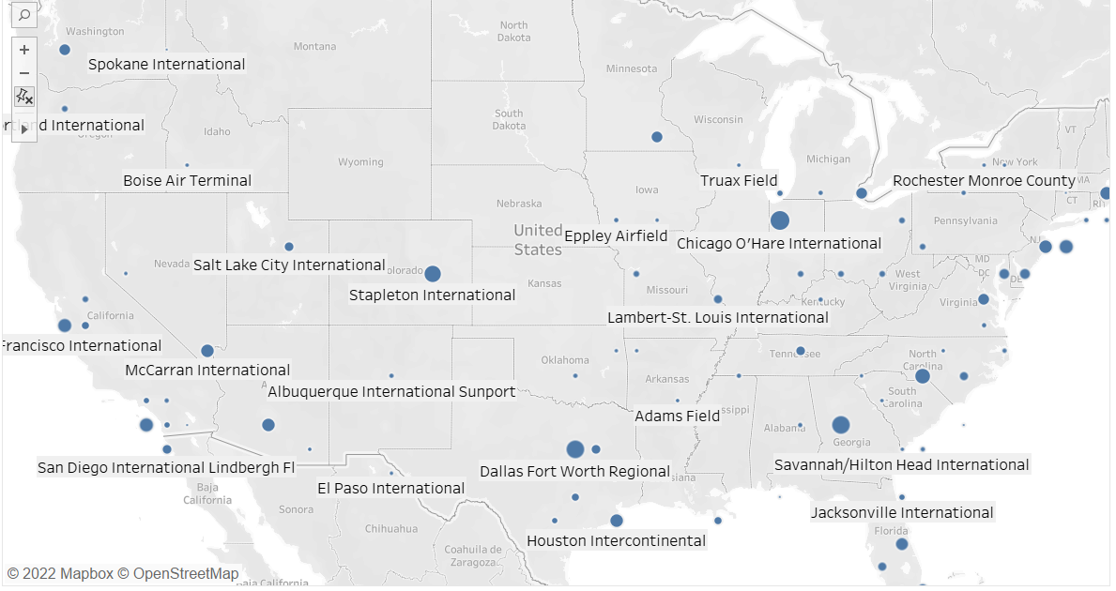

**Delays at Different Airports**

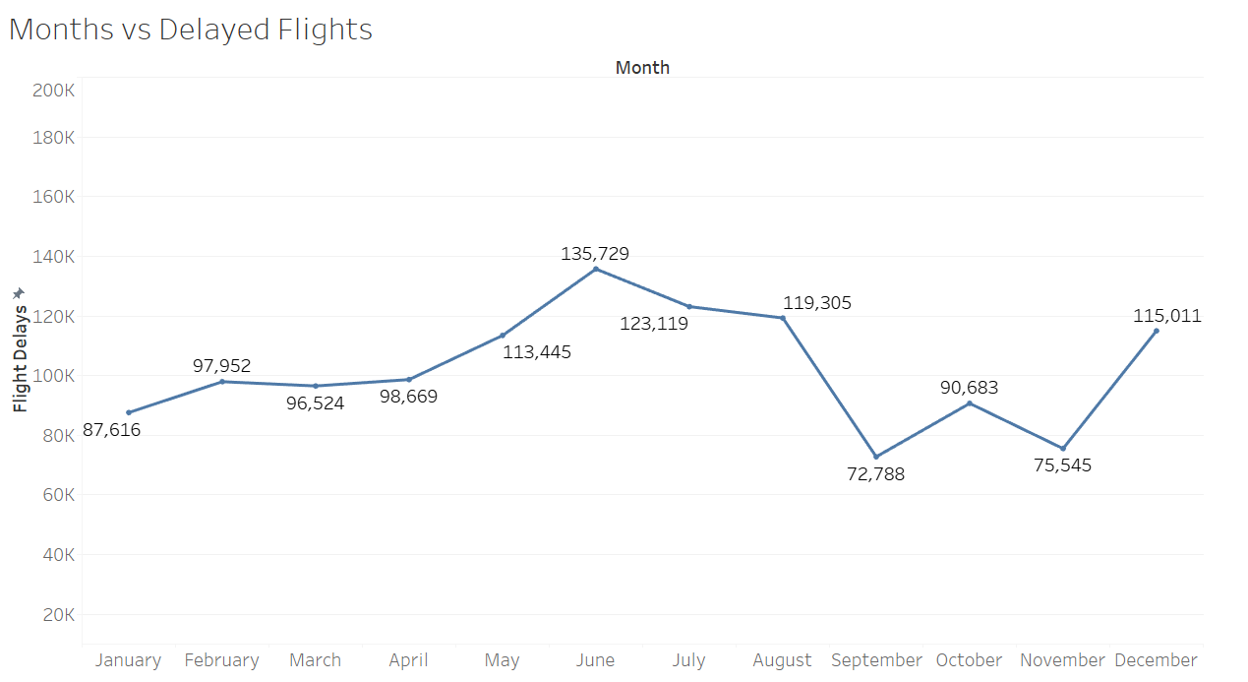

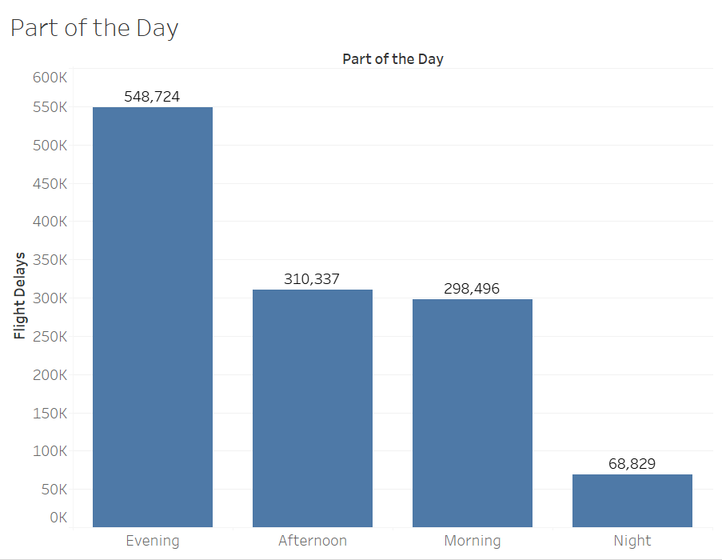

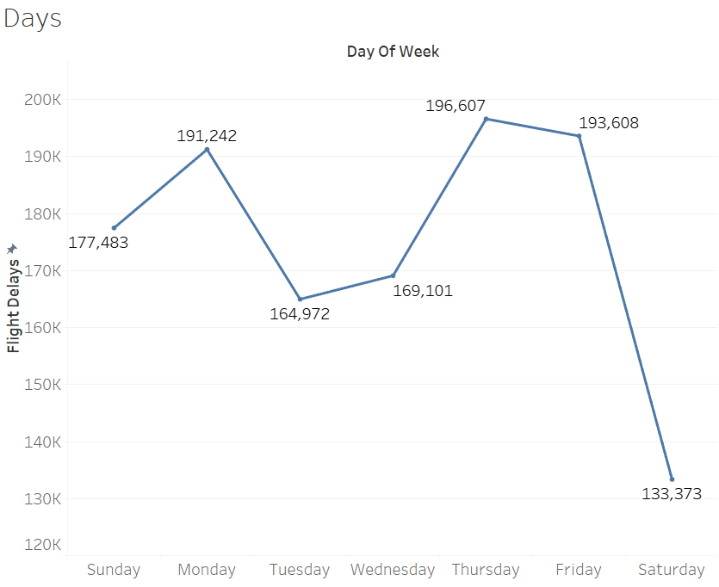

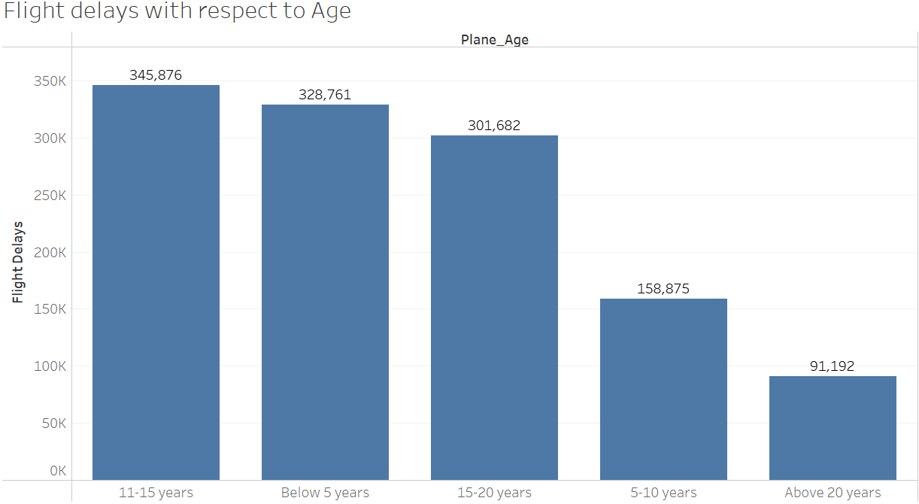

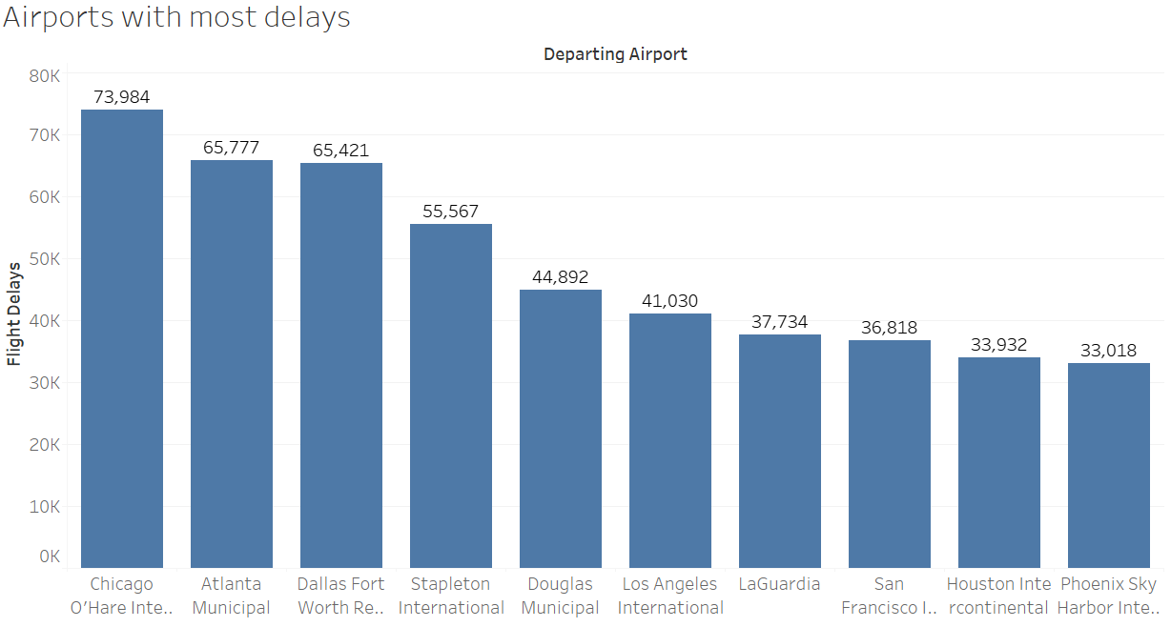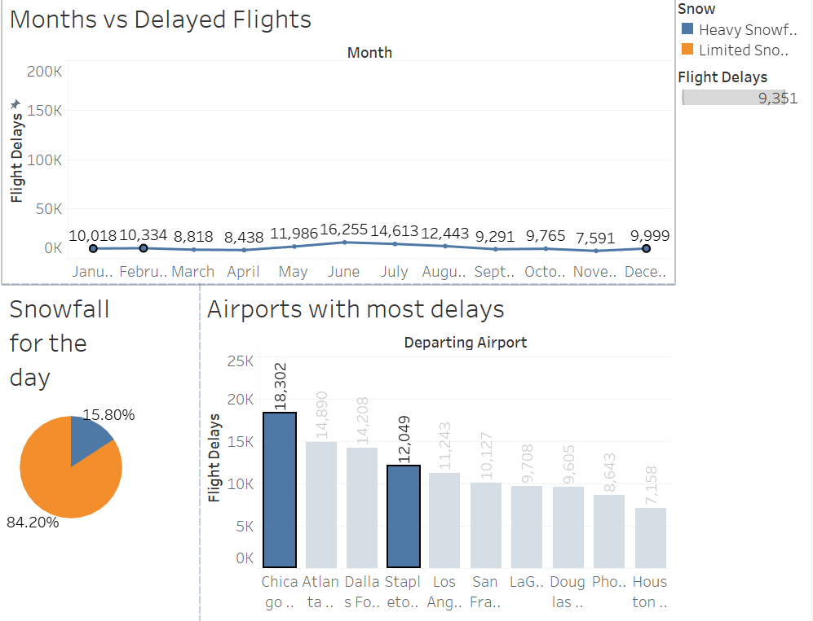

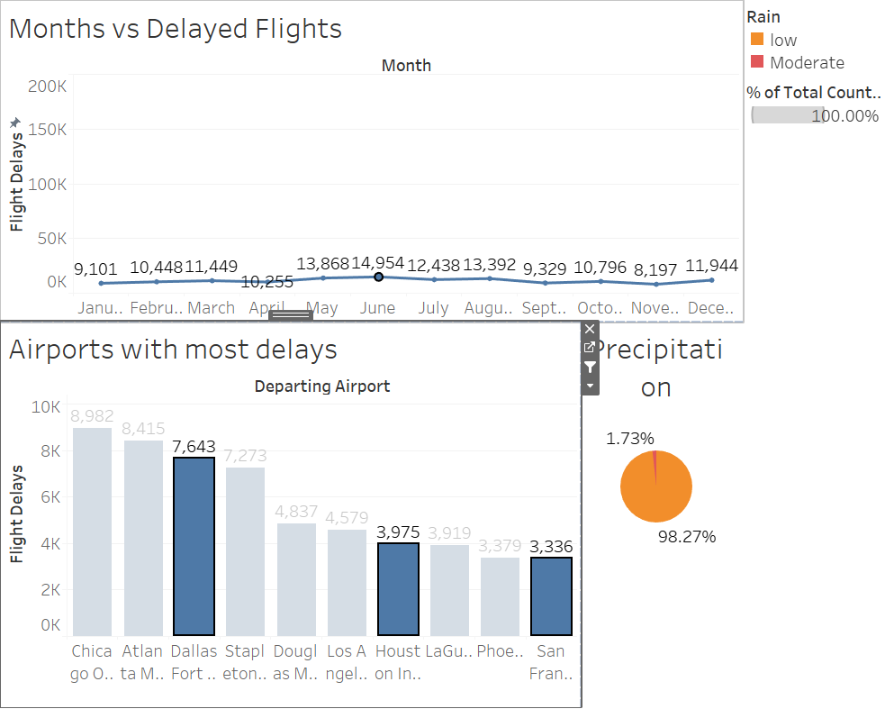

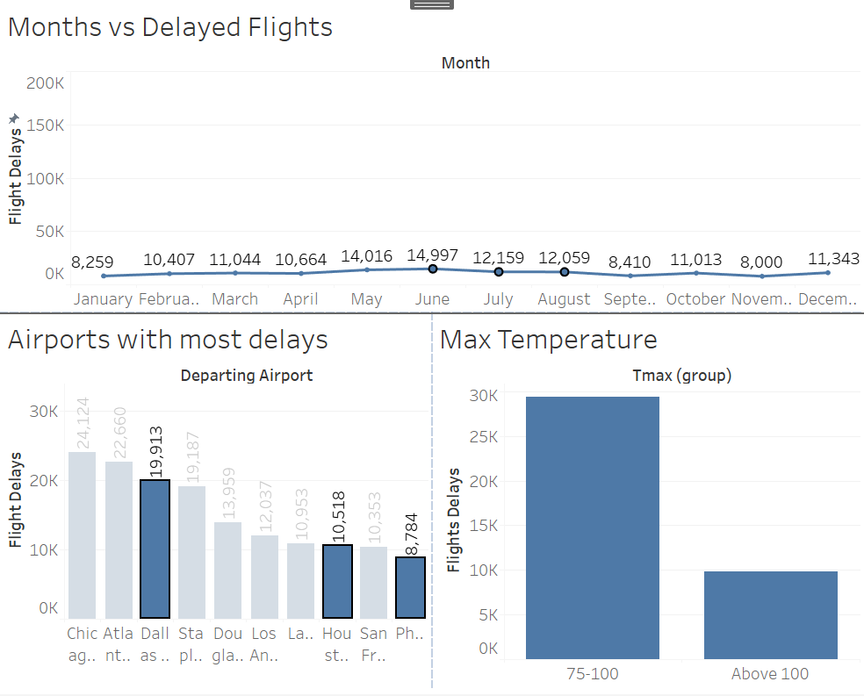

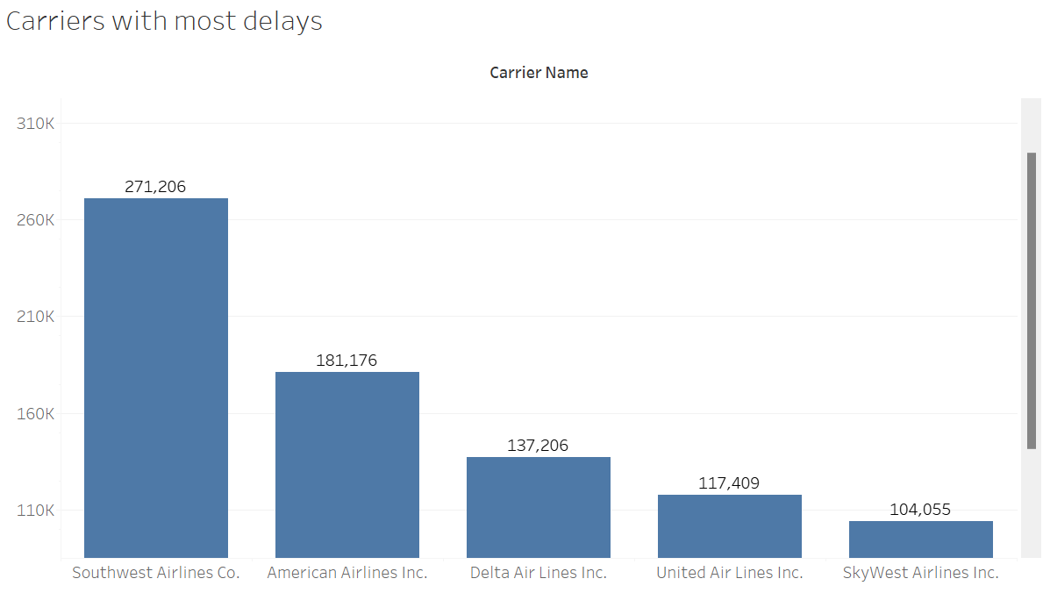

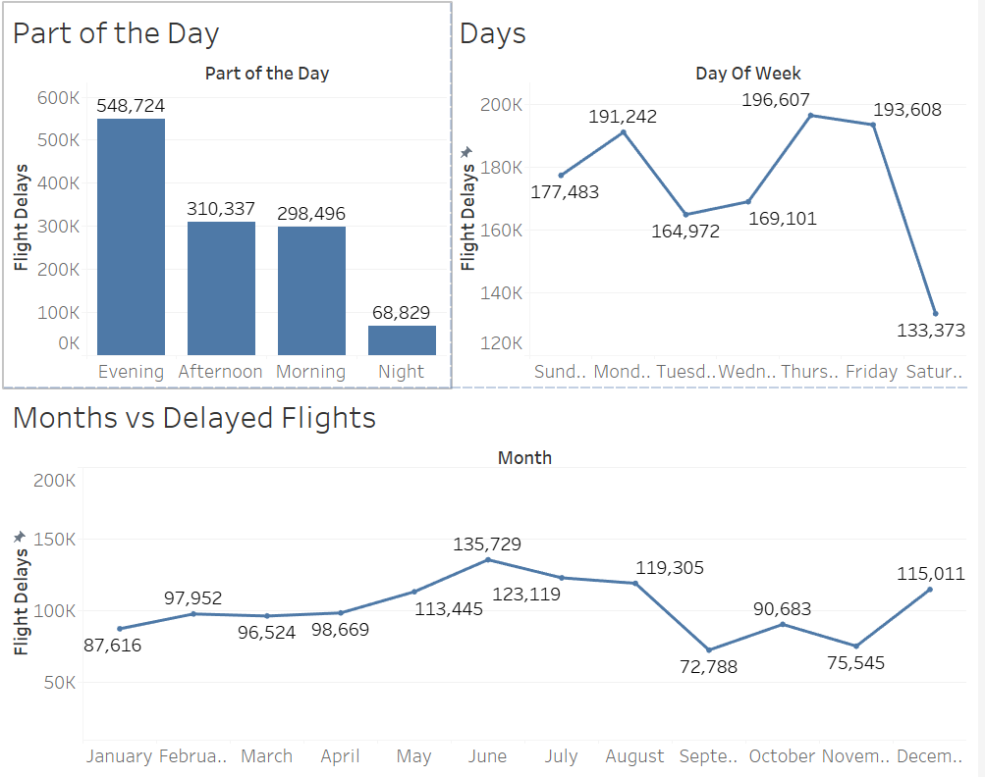

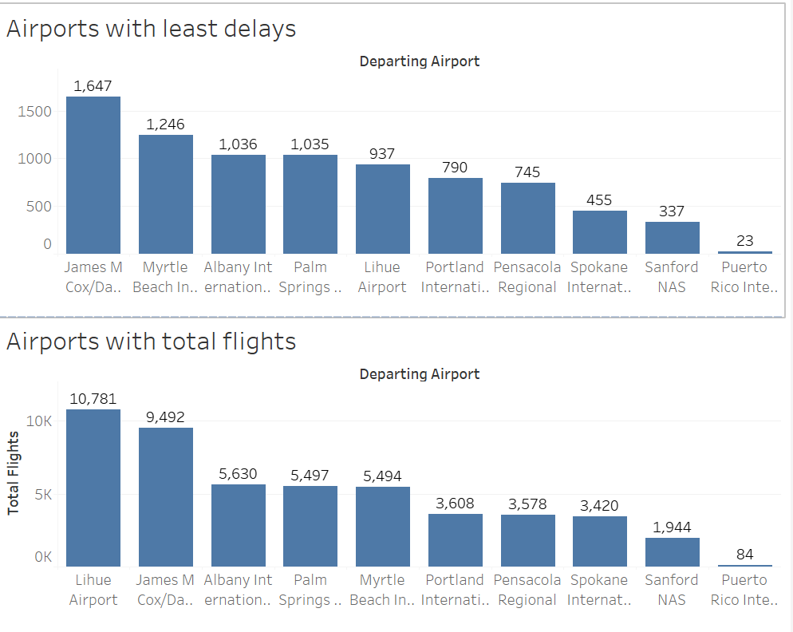

### Data Validation for Visualizations

To ensure data consistency and accuracy among visualizations with the original dataset, the following test cases have been used:

**Case 1**

Total count check:

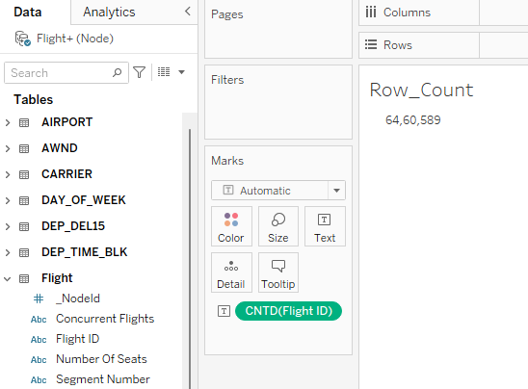

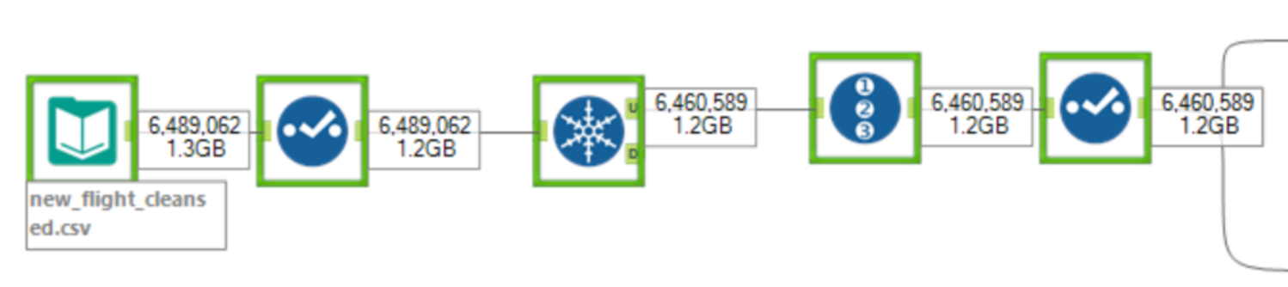**The metrics from the visualization match the actual values from the source dataset.**

## System Integration and User Acceptance Testing

### System integration tests

System integration tests were performed on the entire data pipeline and the front-end visualization.

|  |  |  |
| --- | --- | --- |
| Test Case | Description | Test Case Passed/Failed? |
| CSV File in the source directory | The CSV file should be picked up by the first stage in the pipeline and the pipeline should transition to the next stage. | PASS  CSV file is picked up by the pipeline and the pipeline transitions from **ReadData** to **DataCleaning** |
| Missing CSV file in the data pipeline | The csv file is removed from the source location, where the pipeline is expected to pick it up. | **PASS**  The pipeline transitions to Failed state since the CSV file is not found. |
| Wrong CSV file provided. | Wrong CSV file is provided. The pipeline should work as expected but data load to Neo4j should fail since the data in the file does not match the Cypher to load Neo4j. | **PASS**  The pipeline transitions to Failed state in the LoadNeo4j task. |
| Database is not started. | Neo4j database is not started. The pipeline is unable to connect to Neo4j to execute Cypher statements. | **PASS**  The pipeline transitions to Failed state in the Create Constraints task since the database is not active. |
| Database active. | Neo4j database is started and active. The pipeline should work as expected and load the data. | **PASS**  The pipeline cleans data, creates constraints, and loads the data to Neo4j. |
| Database is not started. | The front-end dashboards on Tableau should not display any data/visualizations. | **PASS**  The applications fail to load and does not show any visualizations/insights from the database. |

**USER ACCEPTANCE TESTING**

* This was carried out by ensuring the data in the database could be accessed by others to retrieve information accurately.
* When ensuring the data can be accessed and used, the database should be able to return query results on one table as well as on joins.
* The data returned should correspond accurately to the standards of data integrity and data consistency. Below are a few of the queries used to test the Commodity database:

1. Counting the unique Flight IDs

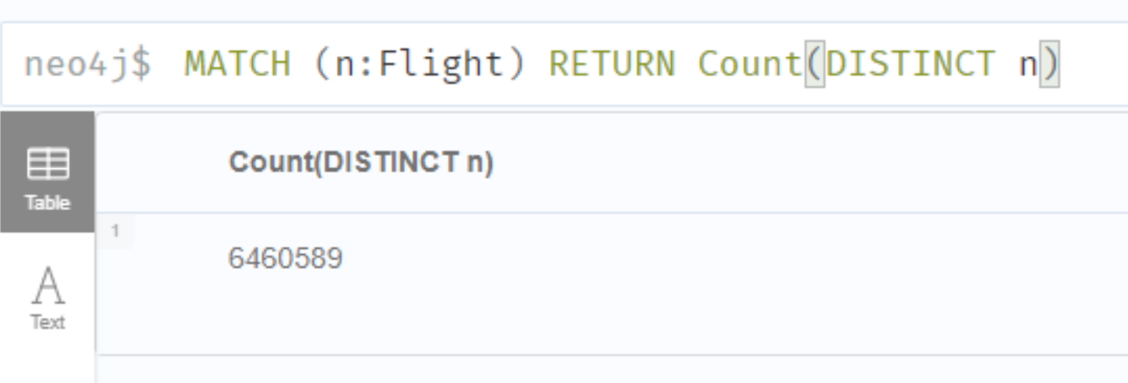

Unique Flight IDs in the processed CSV file:



**Test Case: PASSED**

## Challenges Encountered

* No prior experience with Neo4j: Graph databases were a relatively new concept and there was a major learning curve to understand the differences between relational and graph databases. ​
* Method of querying is also different from the usual ANSI SQL syntax and was a challenge. ​
* The dataset provided had over millions of records – reducing load times to Neo4j was one of the major challenges.​
* Connectivity of the neo4j database to the data visualization tool – Tableau.
* End-to-end integration using Python to clean, wrangle and load the database was a huge learning curve as well.

**RISKS AND ISSUES**

1. **Issue:** No id on any of the data columns in the dataset which had to be handled in a manner that does not reduce the data and keeps data integrity. This was mitigated by creating a new column for ‘id’.
2. **Issue:** The data is not completely trustworthy as stated by the source itself. Cannot be mitigated but analysis must be done only on commodities that are more likely to have trustworthy data.
3. **Issue:** None of the project members have prior knowledge of neo4j which may lead to certain processes being done inefficiently. It may also lead to poorer usage of the database tool and neo4j's cypher for querying. This can be mitigated by better studying the intricacies of neo4j and its cypher language as well as studying better practices when loading and accessing data.
4. **Risk:** Data quality can be a risk as we are relying on the data compiled by a third party. Can be mitigated by profiling the data individually although the probability of this is low as the data has simply been scraped but there is chances of error.

## End User Instructions

### End user instructions for neo4j

* Download Neo4j for your OS (Operating System) from here: <https://neo4j.com/download/>
* Follow the on-screen prompts and install the application.
* Create a new database and use this database in the following steps to load data.

### End user instructions for Data Loading & Ingestion

**Python version:** Python 3.7+  
**Libraries:** py2neo, pandas, pandas_profiling, numpy, seaborn, matplotlib

The data can be cleaned and loaded in two ways:

* Run Jupyter notebook: Neo4j_Project.ipynb

**Run instructions:**

* Download and install Python from here: <https://www.python.org/downloads/release/python-370/>
* Install the dependencies by using the requirements.txt file by running the following command: **pip install pandas_profiling**
* Once Data profiling and wrangling is complete export the data to flat file (included in python script)
* Import Data into Alteryx for further cleaning like removing duplicates, generate a Unique id and then export the file to a flat file
* Import the cleansed file to neo4j project
* Run the Cypher Scripts to load the nodes and relationships and constrains

### End user instructions for Viewing the dashboard

**Tableau**

**Run instructions:**

* Install Tableau desktop and JDBC drivers to connect to neo4j database
* Install neo4j APOC plugins
* Connect to neo4j using connection string or use an extract of the data
* View the dashboard

## 4.0 Velero Screenshots

Project Milestones/Tasks

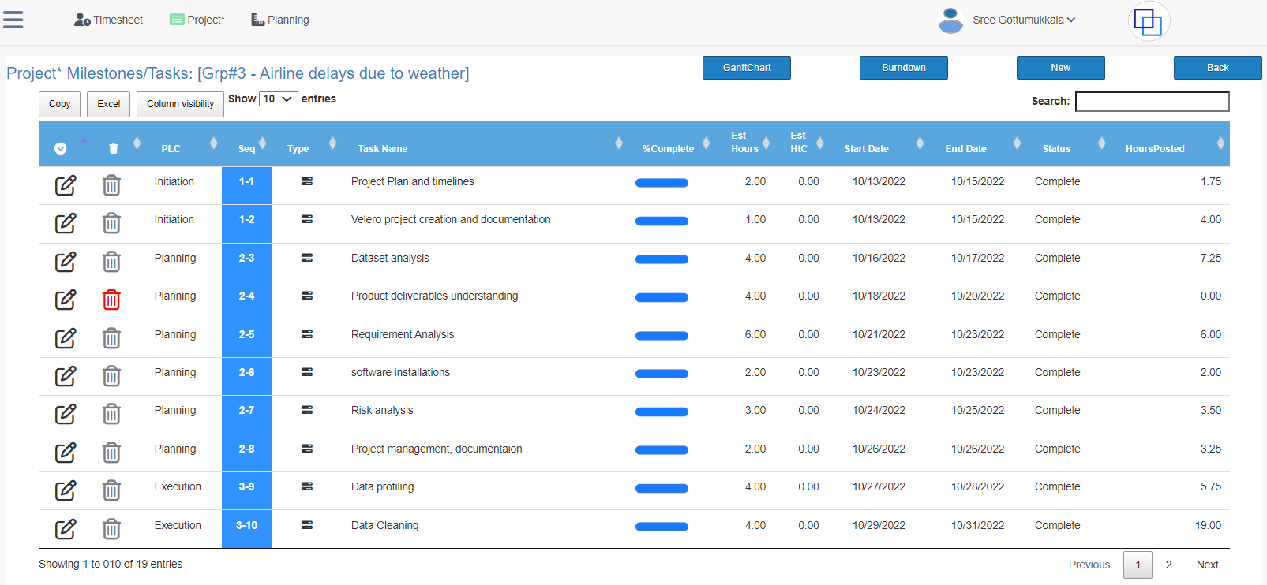

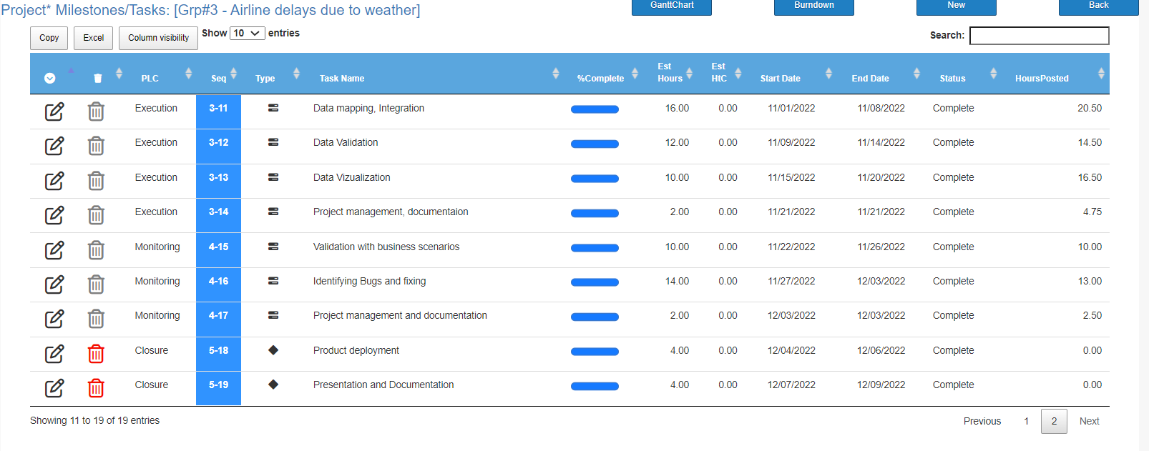

Gantt Chart

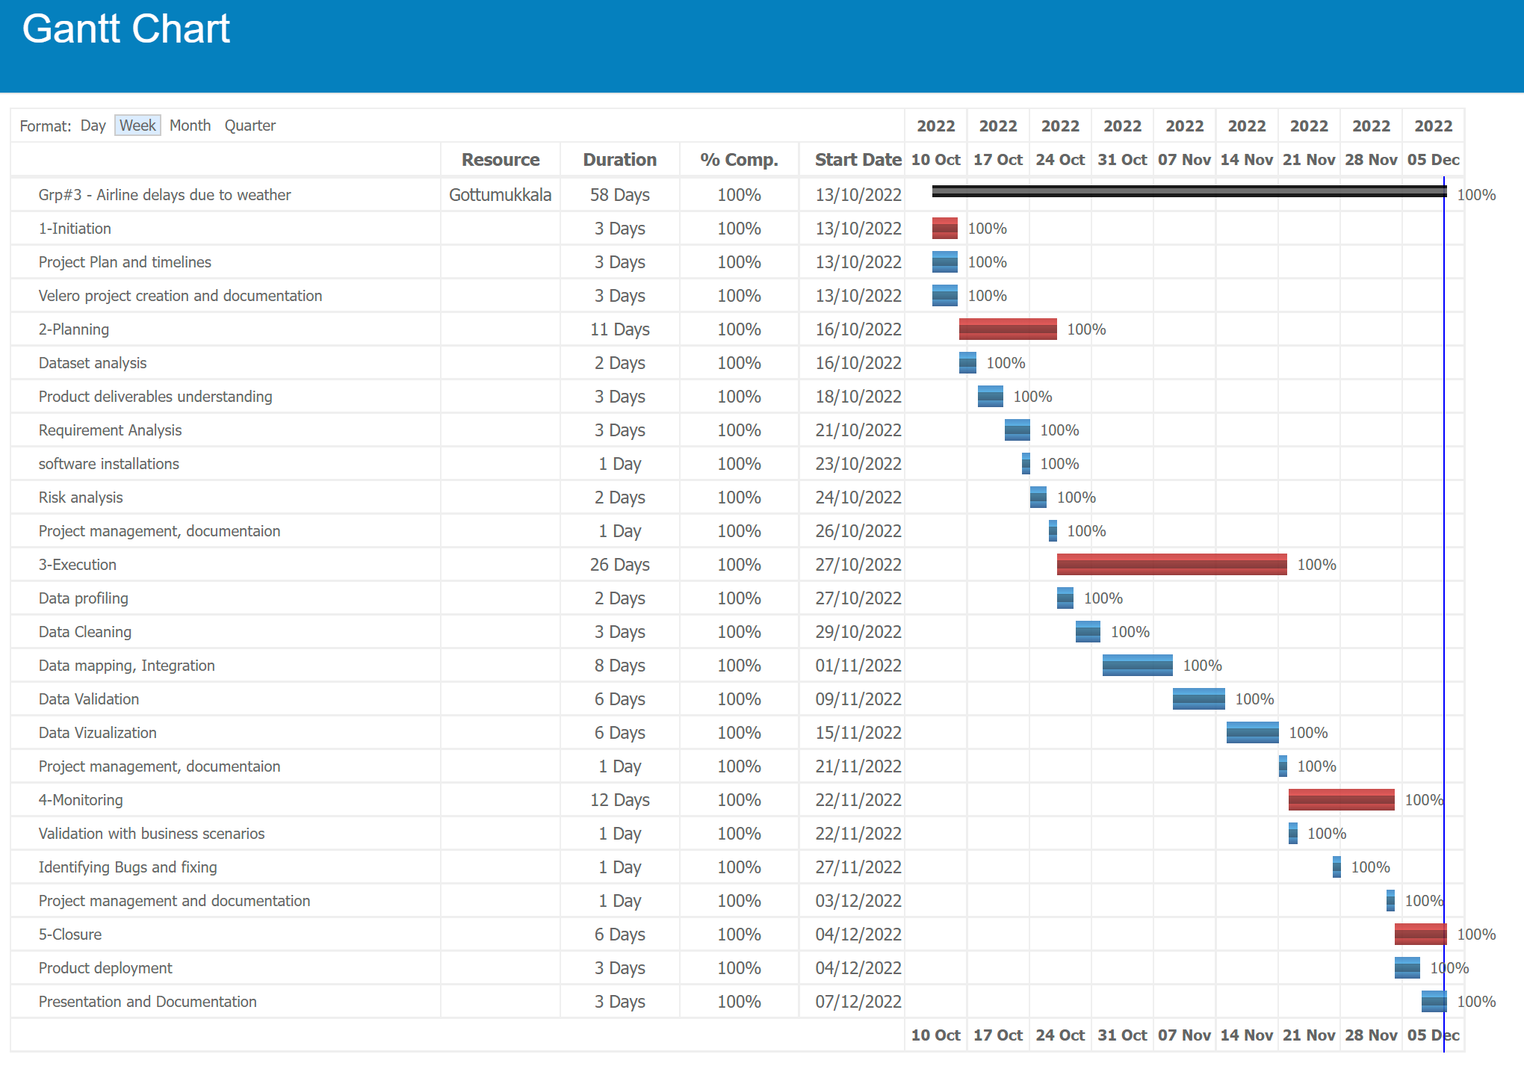

Timesheets

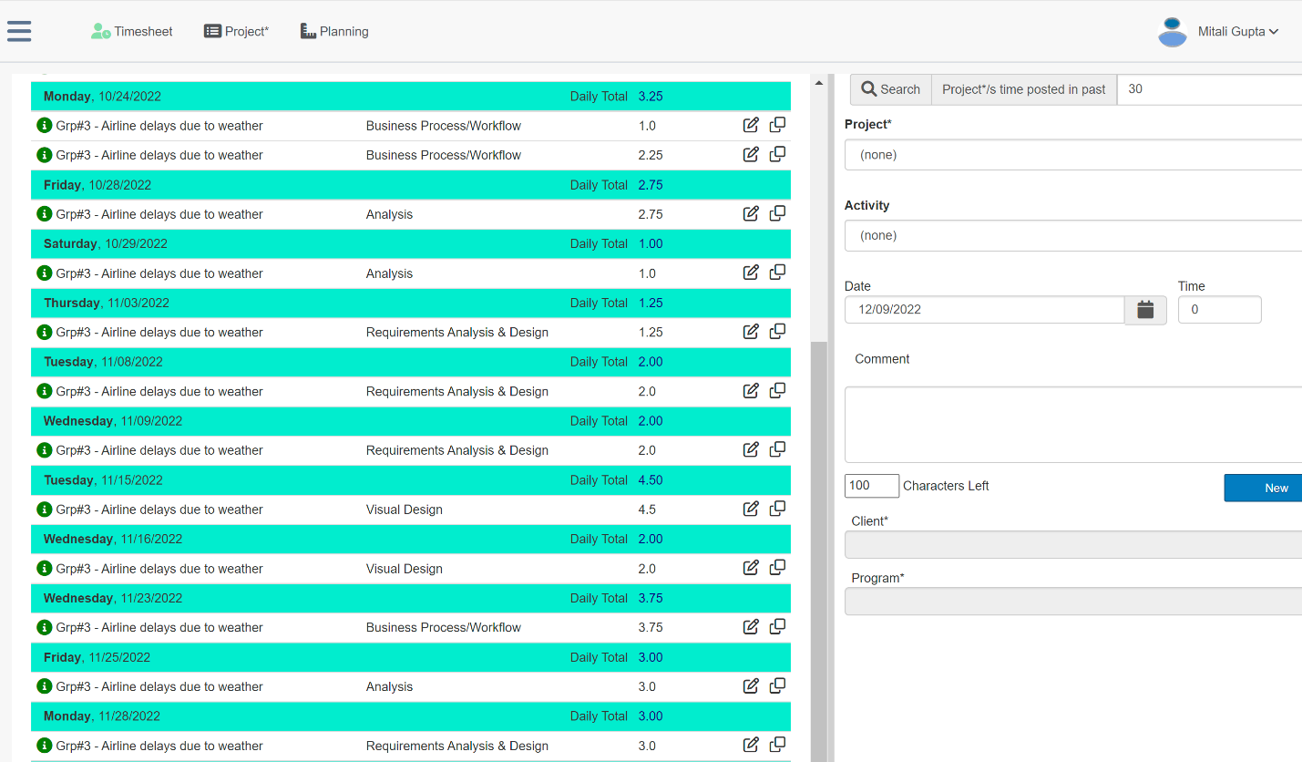

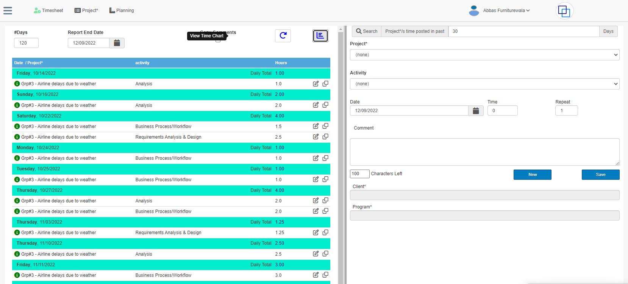

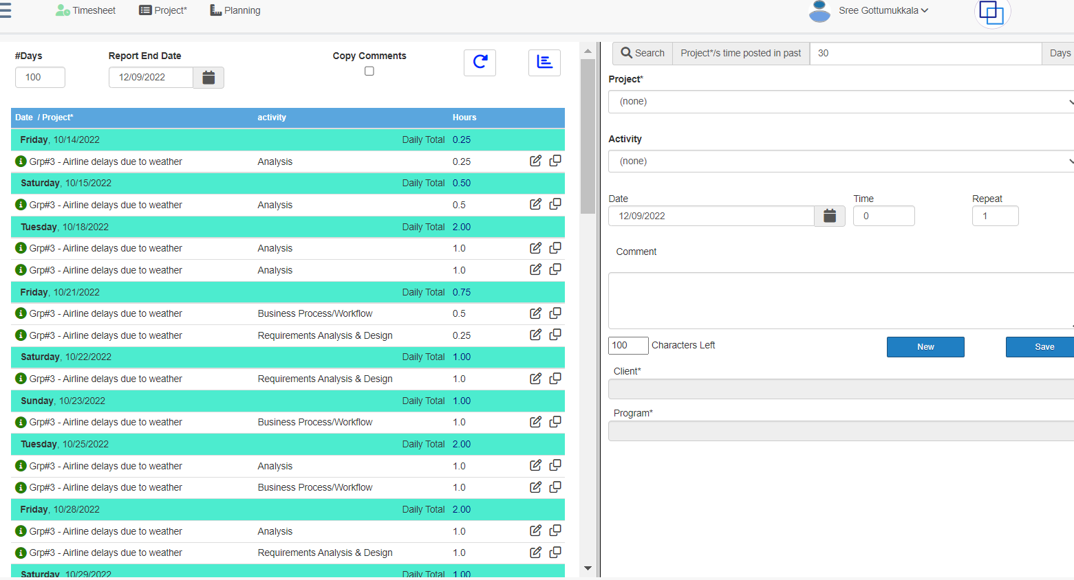

Mandates

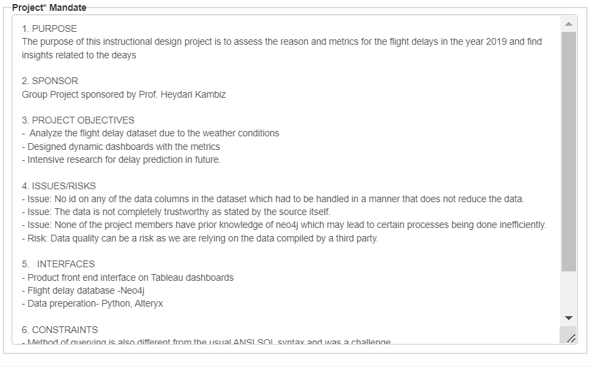

Issues/Risks

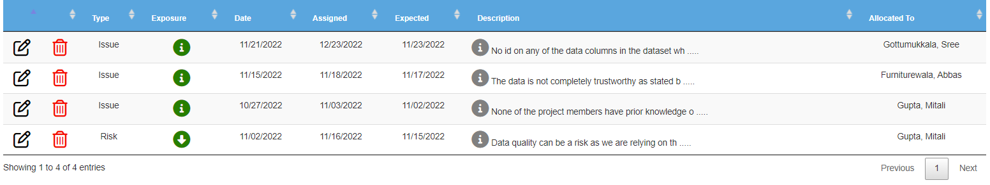

Resource Management

